JUIN 2022

EUREOPEAN BUSINESS & ECONOMICS
INTERNATIONAL BUSINESS
MOLAYNEJAD SHIRINE

Table of Contents
Table of Contents 0
Introduction 3
Module 1: What is economic integration? 4
1. Attempt of definitions 4
1.1. Disintegration Vs Integration 4
1.2. Political Vs Economic 4
2. Economic integration features 6
2.1. Geographical obstacles 6
2.2. Technological obstacles 6
2.3. Institutional obstacles 8
2.4. Cultural obstacles 11
3. Expected theoretical outcomes of economic integration 12
3.1. Economic convergence through 12
3.2. Further growth and competitiveness 14
4. Usual steps of economic integration 14
Module 2: EU integration process: US market integration and EU reaction (1860 – 1945) 15
1. The US market integration process: a game changer 15
1.1. Integration of the US domestic market 15
1.2. Emergence of large US firms 18
2. European reactions (1900 – 1945) 19
2.1. Europe before WWII: great economic rivalry between European states 19
2.2. Industrial development strategy in Europe 20
2.3. Economic and political changes from 1914 to 1945 22
2.4. Conclusion after two WW 22
Module 3: The launching of the EU integration process. A US supported process, not so supported by EU governments 23
1. Europe: a US administration project with a triple objective 23
2. US support: the means and process 24
2.1. The Marshall plan 24
2.2. The reactions to the Marshall plan 24
3. First steps toward European economic integration 25
3.1. Launch of the European Coal and Steel Community (ECSC) 25
3.2. Launching of the Common Market: Treaty of Rome 25
3.3. Mitigated outcomes of the Treaty of Rome 26
4. Dominance of “national champions” strategy (1960 – 1970) 27
4.1. National champion strategy 27
4.2. The big dilemma 27
Module 4: The acceleration of the EU integration process (1980 – 2000) 29
1. The turning point of the 1970’s 29
1.1. Slowdown of European Economic growth after 1973 29
1.2. Rising public deficit in Europe 29
1.3. Intensification of international competition 30
1.4. Shift towards post-Fordist production process 31
1.5. Substantial impact on the European integration process 32
2. The acceleration of the EU integration process 32
2.1. Big business lobbying campaign to remove intra-EU barriers 32
2.2. Dismantling of technical barriers to trade 33
2.3. Implementation of the European Single market 35
2.4. Removal of physical barriers 35
2.5. Better integration of European transport 36
2.6. Stricter supernational control of state subsidies 36
2.7. Privatization of national champions 36
2.8. Larger merger wave of European history starting in 1986 37
3. The wave of M&A impact (1986 – 2001) 37
Module 5: Three structural issues of the EU integration process 39
1. External Economy of scale 39
1.1. Definition 39
1.2. Business clusters in US 39
1.3. Business clusters in Europe 40
2. Is the Euro an optimal currency for the whole Europe? 41
2.1. Functioning of the euro 42
2.2. Weak or strong currency? What is best? 44
2.3. No synchronized business cycles between the Eurozone 44
3. National fiscal policies and transfer or pricing strategies 45
3.1. Transfer pricing in Europe 45
3.2. Transfer pricing from Europe and beyond 48
Module 6: The EU today: facing renewed and challenging competition. (2000 – Present) 49
1. EU firms VS US and China 49
2. Implementation of Wintelism and Modular Production Network 51
3. Tackling the gap between the EU and USA 53
3.1. European weakness in high sectors 53
3.2. More favorable macroeconomics environment for capital accumulation in the US 54
3.3. Lisbon strategy or agenda march 2000 and agenda 2020 : three pillars 54
3.4. R&D intensity 55
3.5. Enlargement towards Eastern Europe - Nice Treaty 2001 56
3.6. Agenda 2020: 5 targets for the EU in 2020 (quite the same as the Lisbon strategy with a greater dimension for Environmental goals) 56

Introduction

The backbone of the course

- Europe: We’re taking Europe as an example because it’s where we’re going to work BUT economic integration is for ALL countries. So, yes, we can adapt the mechanism we’re going to see and adapt it to other countries.
- Integration: it enables businesses to work properly. Integration is when you try to remove the differences.
Definition: you’ve got differences between countries. So, to ensure that economic actors work properly, the best would be that the rules & policies & other regulations are the same. So, the businesses would have the same regulations on different markets. (We ‘re going to see what does the same mean)
- Business: 99% objectives of the European Institutions is to try to develop a framework for businesses. They want to work with companies that are going to work with the European market. For example, the US’s biggest market after their domestic one is the EU market. So, EU will have no trouble working with them.

Overall structure

- Module 1: Defining EU Integration (>< fragmentation)
- Module 2-3-4: Analyzing the European integration process (from the fragmented to integrated) • Module 5: three integration issues at EU levels
  - The currency issues: this currency doesn’t work well, for Spanish, Portuguese. It’s good for Germany, Scandinavian, Netherlands, and Belgium. France is in between.
  - The labor market issues evolution of technology, unemployment, demographics, workers moving in the single market (Brexit: polish people)
  - The fiscal issues: each member state has their fiscal policy (taxation is different in every member state so little integration in fiscal policies). Why? What do companies do when they have 28 different fiscal policies, problems that creates? What strategies do they use?
- Module 6: The European economy today: local specialization & EU supply chains (intra & extra EU): how is the market today? What do they do on the European market? Then what do they specialize in and what it their position in the EU market? How is supply chain organized in the EU? EU is divided in specialization (result of integration market). Belgium would not have this specialization if EU market was not integrated. Now, Belgium is specialized in SC but maybe in 10 years no, so we must anticipate.
Example: if Germany is not going to do the same cars as today, they can either become stronger or weaker, so they need to anticipate 25 years from now. They’re asking themselves “will I have my job in 10 years’ time?”

Module 1: What is economic integration?

1. Attempt of definitions

1.1. Disintegration Vs Integration

Disintegration
- Belgium: Vlaams belang wants to divide Belgium in two: they want more decision to the regions and make the center weaker.
- Catalonia, Spain: they have a good position to deal with European union (North) compared to
Andalucía who is further. Therefore, Catalonia is the most important economic partner of the European market, with 20% of GDP of Spain. So, there were fighting for their independence because they are rich from the European market and don’t want to share with the others.
- Italy: they have a regional economy, the North (closer to EU market) and the South are disconnected.
- Ireland: went from one country and one center to 2 countries with 2 centers.
- North and South Korea
- Brazil: you have your border, then each region has it’s rules.

Integration
- Montenegro, Serbia, Macedonia, Albania, want to integrate the EU market but they might disintegrate from other markets.
- New silk road “Belt & Road” initiative (BRI): attempt by the Chinese government to connect better the Chinese market to neighboring market and the EU market. Mainly transport, railways, maritime and infrastructure (harbors, airport.). In this project, there is pieces that don’t exist, so we need to connect. The idea is doing a railway from China to Germany nonstop. China wants to ensure to get to Europe within 11 days (now: 15 days to 3 weeks). It’s an economic process because it’s focused on transporting goods, with a small part political. So, this integration is starting with transport but maybe will go into other stuff. We can already find products from China, so why new routes?

1.2. Political Vs Economic

Political integration: it’s going from MULTIPLE political centres to ONE single political centre. The decisions are made centrally, that leads to a unified territory under one single government and centralized institutions.
Examples:
- Duchée de Bourgogne + Brittany + Normandy + Aquitaine = France. They were independent from each other and became one. They had a language barrier, so they obligated to speak French in school to make the trades easier.
- Germany: 36 central EU states unite to form Germany confederation (1815) and complete in 1870.

Economic integration: everyone keeps their own governments but it’s a centralized institution, it is considered as one territory.

NOTE: An economic integration does not mean a political integration (and vis versa) Example:
- Let’s imagine, Belgium splits: North and South. The country is not centralized anymore. But the all the economy links between the N and S won’t stop. So, it’s an economic integration and political disintegration.
- French colonies: these have decolonized (political disintegration) BUT France-Afrique economic bind is very strong. (Economic integration).

Is Brexit a political disintegration?
Since Brexit, the UK is now out the summit, they’re on their own so they’re politically disintegration. In may 2016, a referandum was done to get rid of the UK from Ireland, finally Ireland got his independant excpect one piece of the nothern island. It made a lot of people unhappy, like the IRA. By then, everyone was into the EU, so at least the border disappeared but the problem wasn’t solved. When Brexit was announced, the bomb came: it could start a civil war again. It would mean that all the supply chains between North and South of Ireland would be disrupted (ex: cheese, baileys cross 17 times the borders to arrive to a finalized product). After a long negotiation they got to an agreement. Let’s have a look at this map: Notherne Ireland is part of the UK, so politicaly it’s under the control the government in london. But, the border is at the dot line. In other words, if you must handle with Nothern Ireland from Manchester, you must be checked at the border even tho it's considered to be in UK.

- UK is disintegrated because a border is between UK and Ireland.
- Ireland is economical integrated (for now) because they don't have a border but it's not 100% integrated (North Pound and South Euro)

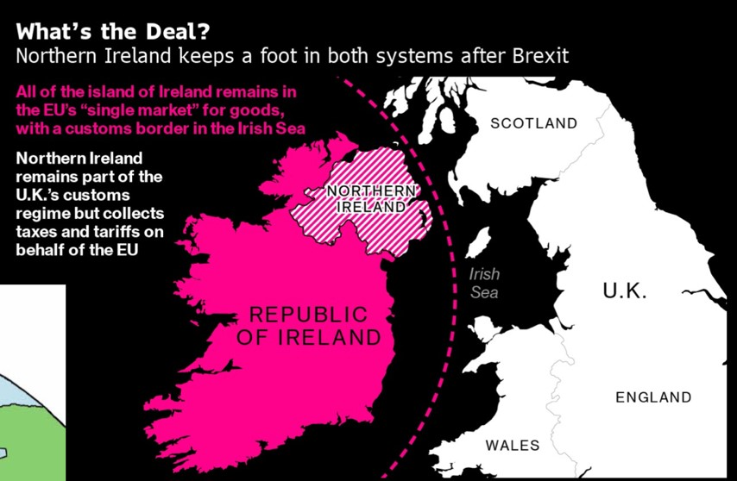

2. Economic integration features

Economic integration is the elimination of various obstacles preventing the free circulation of goods, services, and production factors (labor and capital) on a territory (within region, between various regions, etc.)
Economic integration is the disappearance of all barriers. It turns separate economies into more interdependent economies. It can go as far as a unified market.

The obstacles to an integrated market are:

2.1. Geographical obstacles

Physical barriers
• Alps mountains: separating Western to Central and Eastern Europe, with a few communication paths and many bottlenecks.
ð Solution: Tunnel. Lots of tourist take the tunnels as well (traffic jam). The obstacles have been reduced but you don't have more than 3 tunnels.
- Climate: roads are always frozen between West and East of Russia. The roads need to be done every year.
- Insular position

Distance between economic centers
• Long lasting travels for merchants in the past
• Problems of security (for goods and cash)
ð Solution: transportation improvement reduced distance

Examples:
Indonesia can’t put tunnels because of the ocean, they’re geographically fragmented.
From Bruges to Italy, would take up to 6 months + a lot of steeling because it was a luxury road. So, it would take 1 year to do the round trip. That’s why 99% of the trades were done locally.

2.2. Technological obstacles

Transportation barriers
From Brussels to Seville in takes 2 days. But from Mumbai to Calcutta (same distance), it takes 11 days. This difference comes only because of their technology difference.
Progress in transport enables further economic integration (railways, maritime, etc.)

Logistics obstacles
a. Revolution of containership in 1970’s
Today, wherever you go, there is an international standard for containers. Everything surrounding the container has been standardize, the crane has been adapted, so the same material is being used. So, for the companies producing cranes, their market is the whole world (=> economy of scale)
Most of the time, integration is having economy of scale. In other words, you sell more so you can provide to the world at a cheaper price. Advantage for you and your clients!

What is the advantage of container?
- It’s easy to know how many products you’re transporting and to determine the prices.
- Improves the security and safety of the product within (integrity of the SC)
- Before containers, you had to touch the merchandises all the time. Fill the trucks, empty the trucks, again touching it, putting it back into something else. So, now you don’t touch the merchandise -> you damage less the merchandise. It means that they are less workers as well. Technology reduces labor costs. Now, we touch the box not the product.
ð less waste, comparing prices, more time, less labor costs, reduced of product damage.
- + standards.

Why is it an integration?
- Economy of scale: a single product being sold all over the world at large quantities
- Because of the standards, the comparation of price becomes easy

NOTE:
Air transport is not standardized yet.
China wouldn’t be where it is today in terms of SC without the containers. Because even if the rates of labor were low, the cost of transport would’ve been too much. China was integrated to Europe thanks to the containers. Even if China was using the Belt & silk road so the center of Asia will benefit from better railroad and airport infrastructure. Sea transport remains by far the most competitive means of moving bulky goods (longer but cheaper ! than rail and air)

Examples:
- European Commission said to standardize all the chargers. It’s an integration because one charger producer would whole Europe as a market. But everyone doesn’t want that. Apple is disintegrated (you need to buy only from them) and will spend a lot of money to stay that way.
- Apps need to adapt to Android or iOS. It would be much easier to have only one system for the app producers (=> integration). But because of the competition, brands want to keep it separate.

b. The Suez Canal
Constructed in 1869, it’s a breakthrough in terms of economic integration between Europe and Asia. Before the Suez Canal, we needed to get around Africa (more than 19 800 km) and now with the canal created by man the distance is about 11 600 km. Now we have the techniques to travel fast and far. Canal blocked: had to circumvent Africa to be able to reach Europe. There were a lot of disruption in terms of SC.

Communication barriers
A progress in communication is key of an integrated market. Such as post networks, telegraph, telephone, Internet.
Communications barriers have gone down thanks to technology: it has been helping the companies to organize in a more international (global SC) way and produce abroad.
(Instant communication: only one call away)

Example:
The semiconductors in phone and laptop: the design + R&D are made mainly in US but 80% is produced in Asia. It’s transported by air so nothing to do with container revolution, but because they can have instant communication with their Asian producers.
Intel is in California and can have instant contact with their producer in Asia. So, Silicon Valley is much more connected with Asia that the rest of the US. In other words, Silicon Valley is better integrated in Asia than the rest of the US market. Silicon Valley doesn’t care about US, but only Asia. When covid 19 hit, covering the news about Asia was much more important than US.
Here, integration is what matters to you as a producer.

2.3. Institutional obstacles

To good and service flows
- Trade barriers such as custom duties and quotas
There are numerous tolls between the same country’s localities in the past.
For example, there are tolls between provinces and sometimes localities in China today.

- Technical barriers to trade
There are three main kinds of technical barriers:
- Requirements on marking, labelling, and packaging (weights, font, etc.)
- Sanitary and Phyto-sanitary measures (hygiene, safety, restriction, etc.).
- Customs and administrative entry procedures and other formalities
Examples:
- Red Bull used components that were used in wars to make the solders awake and brave. France forbade it and brought it at the European level but didn’t work.
- Differences in railway gauge tracks between 2 areas. For example, the Trans-Siberian train. The rails are different in Ukraine, so on the way, they must change the wheels (10 hours). And change it again in Mongolia.
- Differences in electricity standards: plugs, cables, etc. When making a hairdryer, you must adapt to every country. Adaptation is a cost : less economy of scale.

Solution: Standardize. But, what’s standard? A new one? Or one that already exists? Which one? … 1 billion € per year are spent by companies to follow these issues so they lobby among those to have the right standard. Example: UPS has someone to represent them at the European Public Affairs so they can discuss issues like SC to standardize and make it easier.
Institutions are involved when you must standardize.
So, if you don’t have a standard, you have an institutional obstacle. Sometimes, there is a good consensus on the standard.

c. Monetary barriers
There are several currencies and means of payments. If there is a transaction between two countries with different currencies, they choose the amount that one company has to pay to the other but the value of the currency can be appreciated or depreciated.

Dollars is the international currency for technical and institutional barriers. If you pay and spend only with $, you don’t have to change the currency except when you pay the local workers.
The € has integrating the European market BUT not all have €.
Denmark, UK and Sweden wanted an opt out clause, because they say not to have been aware of that condition. Thanks to their negotiation, they didn’t have to instate the currency.
Most of the eastern country when entering in 2004, signed they will use € when they’re ready. So, what about Poland? On the one hand, Poland has a common border with Germany. Investors produce (Bosch, VW) into Poland at a cheaper price (labor + currency value). On the other hand, France’s competitor is Germany, so they want to see Poland using €.
So, lobbying isn’t only about polish people but also Germany and France.

To capital/investment flows
There are two types of investments:
Foreign Direct Investment (FDI) |  | Portfolio Investment
If you buy > 10% of a company then you take part of strategic decisions, and you must vote, so you’re involved in the economic activity, you part of the decision-making process.  Expand your activity in another country. |  | if you buy < 10% you can’t say you opinion, you’re simply a shareholder. You’re in no control. It provides you some dividend. The purpose is that the share you bought has increased in value. It’s more accessible for the average investor because they require much less investment capital and research.  Exception: if the states have 1%, their allowed to intervene in the decision-making.  In some country, portfolio investment isn’t allowed. They want you to be part of the economy.
Greenfield | Brownfield
A company decides to create 100% new  company, from A to Z | Buy something existing, the activity already exists.

NOTE: this is an international standard percentage, but some companies are flexible.

What are the obstacles?
- Currency barriers such as exchange rate risk
- Control and/or restrictions on capital movements

Tesla didn’t want to be associated with anyone. They waited until 3 years when China finally allowed greenfield investment. China only allowed joint ventures before to protect their own market, exchange knowledge, exchange capital, technology, transfer of skills. That’s what we call leapfrogging (>< step by step).
Let’s take the example of cars: India took the way of learning by doing, you fail and understand better. But this way is slower and you’re alone. It’s hard especially when you have a competitor like VW. Instead, China chooses joint ventures to be able to leapfrog faster and reduce the gap with the competitor.
There are some sectors we can’t invest in as a foreigner; they want to remain national. For example, military defense for security and fear of spying and loosing advantages (Europe was spied by US by CISCO tools and tv equipment where you can trigger the cam without the consumer knowing)

The link with integration: you wants the rules to be the same, not without obstacles but the same obstacles for everyone.

FDI incentives and  barriers | Definition | Example
Local content  requirements | Minimum % of a product as to come from local sources (RM, made in)  It restricts the way you can invest; your strategy will be different. Sometimes the rules are that the local components should not be basic. | Nigeria: produce and services used in oil sector must be 50% Nigerian content
(Ownership restrictions) | Need min/max shareholder  Negative list (sectors you can’t get in) | Indian tobacco Military
Income repatriation  restrictions | Currency controls: common in countries with shortage on hard currencies (dollars, euro, yens) | Algeria: part of the income must be re invested into the local economy.  Philippines: foreign investors must deposit their pesos in local banks in min 90 days.  • If everyone is changing the local currency for another (euro), then the pesos will depreciate.
Domestic sales  requirements | % Of the quantity produces must be sold into the domestic market, only then can it be exported | Indonesia  • When the trade balance is negative, so you want to  balance it
(Export-performance requirements) | % of quantity must be exported | Taiwan: car exports
Technology transfer  requirements | On the condition of transferring technology or do research locally | Tesla accepted to give some patents to China to be able to access the chines market. Chinese are looking for a more sustainable solution (high death rate from respiratory disease) + wants to get in before China is too big
(Trade-balancing requirements) | Investors must use earnings for export to pay for imports
Employment requirements | Right to invest on condition of using local employment.  Allows job creation, fiscal revenues (secure job and income), increase the competitiveness of the labor force (= local labor learns from the company the skills that are not trained locally) | Rwanda: manufacturing and processing industries.

To labor flows
= obstacles related to workers
a. Labor rules and regulations of migratory flows:
• Resident permit regulation. For example, in the US it goes like this:
- An open test
- The lottery
- Website with diploma
- A company needs to give you a contracts
- You go to the embassy, is your skill lacking on the domestic market? you need a proof that it is
- Green card
ð Shows that the US market is not open
- Diploma recognition and equivalence (+ professional translator)
- Social benefits: you can lose some advantages when you change systems. For example, you can lose years in your pension scheme. China will not give any money to Belgium for the pension if you work there for a couple of years even, because the social scheme is different. It can be a barrier to work abroad.

b. Several currencies

Examples of labor obstacles:
In China, you have the right to work and study in your region. But, if you want to study in another city than you need permission, otherwise you’re illegal. Why? In China, one farmer feeds 10 people (in us, 80), so you need more farmers. Plus, without this restriction, it would be like Brazil: the bidon-ville are filled with people that come into the city without a job and no money. They end up building their own houses, no sewage system, no water, etc. Something that China wants to avoid.

2.4. Cultural obstacles

- Language : whatever you do, you have cultural barriers. (Like French and flamish people in Belgium who have not the same references.) The different languages can be a barrier to work.
- Education systems: Belgian know and trust their schools. But other countries don’t, so more difficult to hire.
- Religion, beliefs
- Self-perception of the world : we have to know how our country is involved with other country before going there for work...

ð Jules Ferry laws in France (1881-82), establishing mandatory education in French for primary level

3. Expected theoretical outcomes of economic integration

The point of economic integration was:

3.1. Economic convergence through
Convergence= not trying to have the same product but to converge to have a better harmony.

Let’s take an integrated market: you lifted the obstacles the difference in prices for example is still, there. The company that are not as competitive should find ways to reduce their prices, that’s convergence. Same goes with quality, once the barriers are down, and the countries sell at the same price, but one country has a higher quality, the others must work and converge towards a better quality. Otherwise, the market share is going to go to the other country. So, in theory, with integration comes convergence.
Examples:
Convergence for wages does not mean that it will go up per se, it can put pressure and make the wage lower.
Proof: The single market act is in 1986. In 10 years, (same industry, same product, same quality), we went from a 40% difference in price to 10-30%. It’s not a 100% convergence, but that because there are still some barriers (purchasing power, etc.) but the reduction is there.

Limits of convergence: (cases where integration happened but not convergence)
- No convergence in minimum wage in Europe
- Some barriers can never be taken down: physical, cultural , taxation (no fiscal union: different taxation, different social health, etc. )
- Business clusters: external economy of scale. If the wages go up in Poland (so converge) than the companies are going to move and not converge.
ð Integration can create divergence: high tech demands high wages in areas, and low-tech low wages in other areas The high-tech industry are concentrated is some areas.
How do you stop this divergence? you redistribute. it exists in the US and national level in the EU. But at the EU level you don’t have that redistribution and can’t be rebalanced.

a. Trade creation versus trade diversion
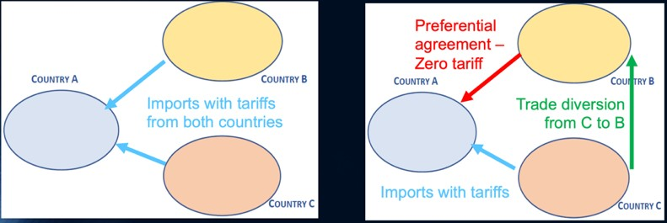
Let’s take country A, B and C.

Left: tariffs between the countries, no agreement.

Right: A and B signed a preferential agreement (0 tariff).

Consequences:
- Trade creation: because of this agreement, trade is going to be created between A and B, because if we’re not paying tariffs, the prices of export can lower, and the product becomes cheaper so more competitive. Companies from A that didn’t think of trading with B, are attracted to B now because of the 0 tariffs (and vice versa).
- Trade diversion: since the country C remains with their tariffs. Country A is going to prefer getting supplies from country B because it’s less expensive. So, some companies are going to move to country B since country A is supplying from there now and benefit from the 0-tariff area. C is losing market shares to B.

So, integration creates trade between the country that are integrated and it diverse trade from the rest of the world.
NOTE: Trade creation doesn’t always cause trades diversion but not always: some country didn’t do any trade but do it when they see the tariffs go to 0.

Example: 65% of the European exchanges are made within the member countries.
Plus, any country outside of EU will have trade advantage from any country in Europe. Trade diversion = company always choose the easiest way: EU instead of US.

  - Equalization of productivity level

We need to adapt and produce more because we produce for a bigger market
ð Economy of scale

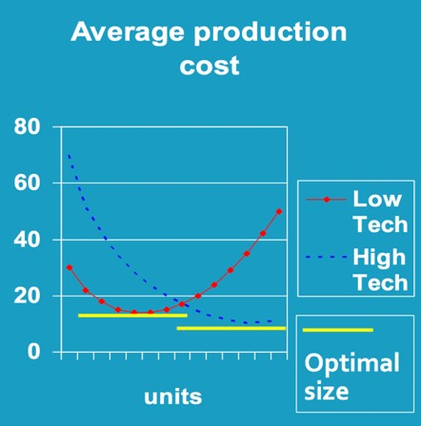
Firm optimal size theory:
Low tech: labor intensive and low fixed cost
High tech: capital intensive and high fixed cost

Optimal firm size: level of production required to decrease average production cost

So, the high tech can do much more economy of scale. Plus they have a barrier to entry (cost high in the beginning of activity)

  - Equalization of wages and prices

Equal in the whole area.
Every country gets the same purchasing power, therefore by products at a price they usually don’t. -> more consumption.

  - Catching up process between lagging regions and more advanced areas
Due to the easy access to all production processes, country that are behind can reduce the gap

3.2. Further growth and competitiveness

- Increased production levels due to increased market size
- Increased fiscal revenues of the state: if we have more trade between countries the state can tax the taxation on individual persons
- Improved international bargaining positions for companies: if Belgium bargain with China alone we don’t have power but with al EU we have power
- Enforced changes in efficiency by intensified competition between firms

4. Usual steps of economic integration

- Free trade area (FTA): removing all trade barriers between the members but keep their own policy regarding the rest of the world. Require rules of origins
Example: USA, Canada, Mexico (NAFTA) have an agreement, custom duties are lower between them. -> trade union let to political integration.
- Customs union: member nations must conduct common external commercial relation. Example: German confederation (1815), Implementation of the Zollverein (1834), EurAsian Custom Union (2010), Armenia &Kyrgyzstan (2015).
BENELUX was a custom union, in Africa and Asia we have it but with more weaknesses.
- Common market: free factor mobility across national members frontiers (capital, labour, technologies, companies should move unhindered between member state)
- Economic and monetary union: unification of monetary and fiscal policies. Setup of a central authority to control these matters. (German unification, Sterling area). Having the same currency. (19 countries in Europe / Western Africa CFA⁵ franc and Central Africa CFA franc)
- Complete political integration: participating countries become one nation. (USA, before being a monetary integration it is a political integration)
ð The four free: Free movement of people, goods, capital, and services.

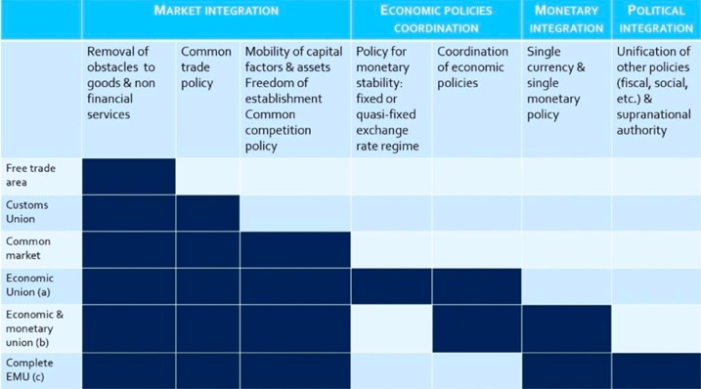

Module 2: EU integration process: US market integration and EU reaction (1860 – 1945)

1. The US market integration process: a game changer

The origin of the US economic supremacy:

- 15th century: the USA didn’t exist. It was the American continent discovered by the European powers (Spanish and French).
- 16-17th century: British, German, French: decided to control different parts of the American continent. Divided in three colonies: New France – British colonies – New Spain
- 18th century: independence revolution in 1776, creation of USA.
- 1860’s: the secession war brought integration into the US.

1.1. Integration of the US domestic market

a. No integrated domestic market until 1860’s

The situation in US before 1860’s

USA was politically integrated…
During the independence, they did a teritorial acquisition and negociated with the european countries. They then became a federal state, which brought a lot of competition between these states when USA was first created. (?)
…. But economical disintegrated:
- Limited transport system. For example, it would take 3 weeks to go from NY to Missouri (1830)
- Each federated state detained substantial economic right:
  - Commercially policy: protectionism within the states. Companies didn’t export to other state, so no competition between states.
  - Monetary policy: different currency and interest rate per state
- Limited protectionism with the rest of the world

The triangular trade

Africa sends slaves to America
ð America sends sugar, tobacco, and cotton to Europe
ð Europe sends textiles and rum to Africa

b. Secession war (1861 – 1865)
The economy was divided in two:
• In the North, The Union: with north easter states (industrial) and Western states (non-slave farming)
- opposed to the expansion of the slavery and wanted to protect against British competitors
• In the South, The Confederacy: cotton, tobacco, sugar cane.
- They want to keep slaves and were for the free trade agreement with Britain (export cotton and import manufactured goods)

1850: agreement with free trade ð acceleration of the economic integration, because of this they created a united market

1860: new president: Abraham Lincoln (in favour of banning slavery and protectionism) ð session war starts

c. Development of transport and communication system Railways:
- Transport cost lowered 50% from 1870 – 1880
- NY-Missouri went from 3 weeks to 3 days

Telegraphs: numbers of users went up

Early development road: 250 000 cars in the world and 60% of them are in the USA.

The transport and telecommunication systems are more integrated than in most Europe economies

One third of the word railway network is in the United States until the first world war.

d. Monetary integration
Before the value of the $ was decided by private bank and due to the secession war they decided to have one currency and one national banking system.
ð National banking act of 1863: creation of a national bank with uniform currency and monopole of interest rates.

Creation of a federal reserve in 1917.

e. Harmonization of technical standards
Harmonization of technical standards completed by the 1880’s to increase trust among the customers.
Examples :
- The 42-gallon standard were adopted by the Petroleum Producers Association in 1872
- Second half of the 19th century: new way of good production -> increases productivity & new industries appeared.

Standardized the barrel of oil (based on whiskey barrel)

f. Rise of a consumer market
US has the fastest population growth due to their immigration.

The US’s strategy was not only having a production market (with a good organization) but also a consumer market. Without consumers, you can’t grow.
In the beginning, the US didn’t have a big consumer market compared to the big territory they had. Based in their strategy, their organised the immigration plan to build up that consumer market. It’s important to understand that this immigration process is not open door to the world.
That’s when the green card policy started:
- You need to show you have money, which means you’re a consumer. And you can open a business and create jobs so more consumers
- You have a skill that’s missing on the US’s labour market. Then you can get a job, get money, and become a consumer.
That’s how they grow their consumer market.

At some point, there were a lot of people dying because of diseases and wars. But the US needs a lot of farmers to feed the people. They decided to attract people into farming by dividing the lands and offering it for cheap (not free). So, good farmer in Ireland that want to escape can come to the US and become owner of a piece of land.
That ownership was important because you can go to the bank and have a guarantee. And that gives a purchasing power and capital power. Therefore, you become a consumer.
- Homestead act, 1862

There is a big difference with the Europe market compared to US.
In the US, the people could consume products In Europe, they were a lot of rich people that “made in USA”. The US market is more owned the poor people that couldn’t be homogenous (lower degree social disparity, consumers. harmonized technological standards, national marketing strategies).

- That’s why, the US proposed the American Dream: you can have a land and find gold. So, USA became a melting pot.

In 1890, the US GDP is 50% higher than GB (first economic power at that time).
In 1928, the US GDP is 33% higher than the 20 large economic economies combined

The increase in US is based on people being welcome in US territory and not because of a baby boom. The US is building up their market through migration.

1.2. Emergence of large US firms

a. Second industrial revolution What is an industrial revolution?
New series of technology that are emerging. The technology that are appearing will have impact on almost everything, not only have impact on the product but it can spread and be used in all sectors.

Industrial Revolution I: (Great Britain) steam power, new energy that you can use.
ð boats are changing, train, manufactory textile industry, …

Industrial Revolution II: (USA, Germany)
- New production techniques: steel was used a lot (rails, buildings, etc.). There came the Bessemer system, it was used to produce more steel. The US was in need, so they paid a lot for people to come up with new technology. Europe is behind.
- New industries: chemical, electric equipment’s (new source of energy), cars.
- Systematic application of sciences and industry (R&D)
- Taylorism (scientific division labour) and Fordism (assembly line)
- Multidivisional firm: specialized in law, finance, marketing
- Opportunities for economy of scale (mass production from Fordism: “the US citizen can choose the colour of his cars as long as it’s black”)
ð It changed everything

In Europe, they had no private cars (only taxis.), but in the US they already had a land and a house, so a car was not that expensive to them. At the end of the 19 centuries, so they had to produce affordable cars because the demand came from middle class people. The price went down because of the assembly line technique: the workers who made cars, had very low wages because the workers didn’t have to have special skills to made cars. Also, they only made black cars. Thanks to the mass production, Ford did economy of scale, and got cheaper RM. So, the cars became cheaper. Another strategy by Ford, was to give cars to his worker, to attract people: if they can have one, everybody can!
It was common in the US to have cars.

Revolution IV (today): AI, block chain, internet of things (you will be able to connect almost anything, so the internet will not become only for some stuff, but also car, fridge,…)

b. Emergence of US prime movers 1870 – 1900
At that time, big companies like Ford, Westinghouse (electric), DuPont (chemmical company), etc. Can produce quantities who are larger than the US market. Therefore, they start to export to Europe (a bit to China to).
When US products arrived in Europe at a cheaper price, Europeans said that it was commercial invasion and Americanisation of the world. Just like what US is saying about China today…

There are prime movers. It’s a term used to designate a company that not only export but also that export technologies for the first time on a market. So, that technology is present on the domestic market but not yet exported at a world level.

The perspectives for growth are better in overseas markets : US prime movers export and open subsidiaries in Latin America, East Asia, and Europe.

Origin of the world’s 100 largest firms in 1912 are 57% in USA. Why?
Europe was not as integrated: couldn’t benefit from the second industrial revolution.
USA: integration of their market (all barriers were falling) + second industrial revolution (new technics and new technology which increases the production)
ð Production increased > sell more > consumption raise > benefits of the firm increased > wage increased > production > etc.

2. European reactions (1900 – 1945)

2.1. Europe before WWII: great economic rivalry between European states

EUROPE | USA
The markets are smaller  UK is the main economic power, considered at the first economic power (textile sector) No rationalization of production capacities Competing powers: French and Germans companies couldn’t merge easily (different countries)  A lot of small companies, less economy of scale  Small consumer market  Protectionism: customs between French and  German  Great competition in Europe, leading to defensive cartel tactics and aggressive market conquests  Technical and trade barriers,  ð Fragmented market | USA is UK’s contender  Companies from different state can easily merge  Got rid of small companies to do economy of scale  Big consumer market
The UK = dominant power: why? They are the first to make their industrialisation in 1820 with the “Oil, iron and coal”, they produce 80% of the all production. They had also an important part of the textile sector. They have an economy based on free trade (UK controlled strategic points like the Suez canal and had a lot of colonies in all the continents, before Wall Street the main exchanges happened there).

France = the second most dominant economic power. After France come Germany but Germany was not competitive enough. Those two countries were more protectionist than UK.

2.2. Industrial development strategy in Europe

Europe followed a national strategy. There was no discussion about European market, every solution to every problem was done for themselves.

The national strategy was based on two kinds of policies:

a. The implementation of protectionist policies at home
Most people wanted to reinform protectionism; it was like an economic war.

Each country would prevent others European country or the US to come on their domestic market.
How?
- Great rise in custom duties:
  - Germany (1879) increased tariffs
  - US (1890) increased to 48% with the Mc Kinley tariff act, then up to 57% with the Dingley tariff act (1897) ® highest tariffs because they want to protect their big market
- France (1892), Méline Law
- Dumping practices: to sell goods at a lower market price in another country (losing money). You remove all competition. Then, you bring the prices up since you’re alone on the market. You lose money at first, but you get subsidies by the state. And at the end, you have a ware!
- Use of marketing strategies calling on “consumer patriotism”.
Example: They invented “made in Germany” but in a bad way because the British didn’t want German products.

In the US, companies became more and more competitive. Therefore, they wanted to expand their production but couldn’t be due to protectionism. That’s when they started colonial empires at international level.

The UK was the only country without a protectionism policy because they were considered the first economic power and thought that even tough products from emerging countries would arrive on their market, British products would still be more competitive (they were wrong, that’s why we see an increase of their tariffs during the 30s).

b. The edification of colonial empires at the international level
Since your market is small, instead of economy of scale, you need to find other solution to make your product cheaper. You go to a country with cheaper RM et labour force.
ð Colonization: the beauty of colony is that RM are sold to the power and the consuming product in the colonizing country will be from the power country.

So, colonies help:
- Provide cheap raw materials and reduced production costs
- Provide commercial outlets and privileged/exclusive consumer markets
- Intended outcomes: reach some economies of scale

The German Empire
Germany was a late country. The empire came at the beginning of the 20th century.
Germany had little part of territories spread around. They didn’t have capital, so they were not present in any colonies in America. Instead, they colonized the places in Africa that France and UK didn’t find interesting.
The US and Germany are the newcomers that are perturbed the balance in the world.

They need to have more consumer for the economy of scale. They have an idea: we need to have a way to Asia. Since they didn’t have block of countries but were spread, the SC for Germany was difficult…
They had to find solutions: ask to the countries (Austria, Hungary, Ottoman empire) who were on the way to Basra (Irak), if they want to join them to deliver product to Asia and build a railway with them (because they were all having the same problem) ® BBB railway

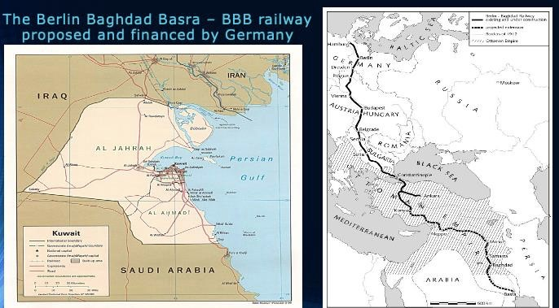
At first, they were sceptical because they didn’t want to work with ottoman empire, but people were interested to finance.
Finally, the project got on and progressed until they reached Konya.
The British and French started to get scared: they realised that it could be a real transport alternative. So they both decided to go to Basra and take a piece of that costal territory (where the harbour would have been thanks to the deep waters). Today, it’s Kuwait.
Germany is now stuck halfway, there were again stopped by the French and UK. The only way out for Germany was a war. That’s the start of WWI… The BBB railway was never finished.

Why Basra?
You can build up a harbour, your products will go by boat to Asia. Current examples: this project rings a bell with the new silk road, belt, and road initiative.

Disadvantages of colonial empires
- Colonies are scattered worldwide: high distance and transport costs
- Consumer patterns are not homogeneous: you can’t propose the same product from UK to the colonies so you’re losing economy of scale.
- Organization of production at the colonial level is not as efficient as in the case of a big single market
- Some countries do not even benefit from important colonial empires such as Germany, Italy, leading to WWI

2.3. Economic and political changes from 1914 to 1945

a. Acceleration of US MNE’s penetration in the start of 20th century
- The WWI effects
  - The US benefited during WWI: they gained economy of scale because they provide goods that EU couldn’t anymore. They supply all the countries from 1914 to 1917.
  - They came into the war only the last year. Why did they join? Because of the Soviet Union problem, US needed WWI to be over so they could deal with Russia. (cold war in ’47)
  - The US becomes the larger creditor in the world (lent 14 Billion$)
  - Became the gold reserve of the world

- US multinationals invest in Europe after WWI: 1300 US subsidiaries set up

b. Integrating Europe politically and economically as a solution
The war is over, what to do now?

That’s where the European project emerges. Some famous people started talking about it:
- Count Coudenhove-Kalergi and Aristide Briand: if we want to become stronger than the US we need a European market. A lot of people didn’t believe in it.
- Nazi project: Hitler explains that if Germany stays landlocked, punished and without export then they need to create their own market for export. The Nazi regime is considering they must create a European market for the German products. They will get supply from the East (by destruction of industry and population) and sell it to the West (richer consumers). Germany takes the lead and turns it into an integrated market.

2.4. Conclusion after two WW

Weakening of European states and reinforcement of the United States :
- 40 million casualties, in particular in Eastern Europe and Germany;
- Economic damages : infrastructures, real estate, production capacities; they were able to develop their industries due to the war
- Financial costs : foreign currencies and gold reserves exhausted;
- Greater economic US power : distant from the battlefield, supplier and lender of European states at war.

Greater fragmentation of the European market:
- Europe divided into two political spheres of influence after Yalta agreement
  - Communism with the URSS
  - Capitalism in Europe and US
- Protectionism comes back to the fore after the war:
  - Financial restrictions:
  - Support to national industries.

Module 3: The launching of the EU integration process. A US supported process, not so supported by EU governments.

Europe was divided after the cold war (1950).

There was more state intervention:
- Support to the demand and substitution to private investments: Keynesianism
- Social discontent and communism: Welfare State
- Need for more funds

It was more fragmented:
- Infrastructure and industry
- Dollar gap
- Protectionism
- Yalta and Iron curtain

Beginning of European integration ideas:
• European organizations
- Two divisions :
  - Federalists and unionists
  - Which countries?
- Hague Congress (1948) and Council of Europe
- Benelux

1. Europe: a US administration project with a triple objective

First objective: a US containment policy against communism expansion in Western Europe There was a communist political threat in Western Europe due to:
- Cold wars between US and URSS
- Germany: stumbling block of divided Europe. the East was dominated by the URSS whereas the western part was controlled by France, UK and US
- Rise of communist parties in France, Italy, Greece, etc.

To stop communism and recover to industrially, they use the American economic model as an alternative to the communist ideology:
- Marshall Plan : put forward « the assembly line against the communist party line »
- Shift to mass standardized production (Fordism) in Europe to enable European firms to benefit from the same economies of scale as their US counterparts ;
- Thanks to economies of scale, generate productivity gains and increase both investment and wages;
- Promote mass consumption society and the « American way of life ».

Second objective: strengthen European military capacities against URSS
Create a European integrated industry for defense with economy of scale Include German military capacities into the integration process ð It’s a way to limit conflict between countries and be more powerful against communism

Third objective: create outlets for US manufacturing sector
US firms face an overcapacity in 1946 (end of economy war).
It creates an easier access to the European market through integration.

2. US support: the means and process

2.1. The Marshall plan

It’s part of the European Recovery Program established by the US:
- Transfer of technology and of a large-scale standardized how-to to European firms
- Financial help

“The substance of such integration would be the formation of a single large market within which quantitative restrictions on the movement of goods, monetary barriers to the flow of payments and eventually, all tariffs are permanently swept away”, statement by the US administration in charge of the Marshall Plan, 1949
ð Consumer market integration
ð Defense industry integration
So, it helped condition to the construction of a European integrated market

2.2. The reactions to the Marshall plan

UK  There were against the Common Market plan. Belief that German firms will win on the continent  Pursuit of an « imperial preference » for the  Commonwealth¹⁰  West Germany  Looser of WWII  Wants to maintain the Franco-German axis to keep West Germany in Western Europe | France  Colonial markets are becoming less important  In favour of a highly protected Europe versus  US competition,  Take advantage of the German weakness to take the lead of Europe.  Benelux  Dependent small markets,  Failed attempts to promote a Federalist Europe  They wanted the integration

3. First steps toward European economic integration

3.1. Launch of the European Coal and Steel Community (ECSC)

It is the first step to the economic integration – the first treaty: it is a common market only for 2 products: coal and steel in the beginning of the 1950.
It is a peace issue: a supernational authority controlled the production and the price of coal and steel and by this common control the war was impossible between those 6 first countries. Those materials were used to produce weapons so we wouldn’t have known if a country was producing weapons. The downside is that the members continued to be protectionist in the other sectors. It is a liberal view: the market (O and D) is leading the production. But on the upside, it stabilized the prices.

Why coal and steel?
- Importance of these two strategic commodities for the reconstruction of Europe
- Problem of distribution : Germany and Belgium are net exporters, France’s fear of once again Germany. It’s good to share the resources.

The ECSC is signed up in 1951 and enforced in 1952 for a period of 50 years (ending in 2002).
French and German production of coal and steel put together under a High Authority’s management:
- The High Authority is the first European supranational institution with real power
- Its powers include: remove tariffs, fix coal & steel prices and volumes, controls unfair competition practices (forbids cartels and controls mergers)
- Helps a better rationalization of coal and steel production capacities.

In 1954: European defence community: failure: we can integrate EU in an economic way but not political. (?)

3.2. Launching of the Common Market: Treaty of Rome

“Allemagne en expansion; dumping allemand à l’exportation; demande de protection pour les industries françaises; arrêt de la libération des échanges ; recréation des cartels d’avant-guerre ; orientation peut-être de l’expansion allemande vers l’Est, prélude aux accords politiques ; France retombée dans l’ornière d’une production limitée et protégée” Monnet (1950)

The Treaty of Rome – signed up in 1957 and enforced in 1958
In 1957 the EURATOME (European atomic energy community) and the European economic community (for all the other products and services) : EEC (with the 6 same founders).

Objectives of the treaty :
- Prohibition on quantitative restrictions (internal tariffs, in 10 years)
- Prohibition of cartels / monopolism / dumping : unfair production
- Free movement of workers
- Right of establishment
- Freedom to provide services
- Free movement of capital
- Procedure for the approximation of laws affecting the common market: common agricultural policy, common commercial policy.
- Creation of structural founds: mechanism of solidarity between the countries (Ex: money given to regions with a higher unemployment rate)
- European investment bank: BEI in French: instrument to help the industrial regions.

It was in the treaty but not directly applied.

3.3. Mitigated outcomes of the Treaty of Rome

a. Political and economic changes in Western Europe
• Golden Sixties: you must recover after wars; you must rebuild everything.
The recovery after the war is quick and gross comes back quickly.
The golden 60’s is part of what the US wanted: the US as economic plan has been adapted to company’s (Fordism etc.) and is spreading towards Europe.

The American way of life: all the products that were available for US consumer started to get available for Europeans as well. Products from the US are getting demand and that dynamizes the growth. So, the consumption society was happening during that period, without the full integration process.
But, at one point, when everyone gets the new goods, the demand decreases (development economy). So, they started with a take-off, and now experiencing a process of landing. In 1970’s, everything is slowing down because everything has been recovered from the war.

Income convergence with the US: the average income int eh European country would be around 41%, so not the same as 70%. The period releases that they don’t need a lt of integration to go back to normal. (??)

- There is also a stabilization of the of the Cold War tensions: peaceful coexistence between the US and the Soviet Union

- The US relaxed control on the European integration process. European states become more defensive vis-a-vis the US and US firms and between each other.

b. Some integration steps but resilience of key intra-community barriers

At the institutional level
You need institution to manage this treaty of Rome (civil servants):
- European Commission: it’s an administration not government! they receive a mandate from European council, and they propose solution to implement the mandate. Ways to achieve the objectives.
- European council: they vote on the proposals given by European commission. Unanimously decision.
(Parliament, beginning of 1980’s)

At the economic level
- Creation of a customs union (Common External Tariff - CET) :
  - Improved flows of good:
  - Internal tariffs removed only in 1968
- Resilience of Technical barriers to trade – TBT
Under the Treaty of Rome, state subsidies to enterprises are supposed to be banned, but the reality shows that state interventionism is widespread through subsidies & procurements
- No freedom of capital and labour movements

4. Dominance of “national champions” strategy (1960 – 1970)

4.1. National champion strategy

National champion features:
- Selecting the most competitive companies:
  - Capacity of export
  - Market shares
  - Revenues to the states
  - Technology: you’re the innovator if you’re the only one in the market (monopolistic position)
- National mergers & acquisitions: At first you only have small companies, then you make them work together (merger and acquisition) so you can make a national champion. But some companies don’t want to merge because who gets the control over the other + maybe don’t have the same objectives in long term + you can lose jobs, restructuring (some jobs are overlapping) so economy of scale -> rationalization
- Giving them a privileged access to the domestic market:
  - Using technical barriers to trade (soaring after the removal of custom duties in 1968)
  - Using procurement to help national champions’ development: state is the client.
Example: the police need cars so the police will buy the national cars.
But now, there is call for tenders and open for everyone.
  - Granting national subsidies (in clear violation of article 90, 92 and 93 of the Treaty of Rome but absence of supranational enforcement)

China: they’ve got a list of 120 companies that follow the national champions strategy

At the defence level
• The project of a European Defence Community -EDC is a total failure
• No military integration

At the political level
- Re-insertion of the Western German economy in the European economy
- But no real political integration

4.2. The big dilemma

There is a persisting need to contain the penetration of large US MNEs on the European market and to reach the « American » scale.
They entered easily on the market, they opened subsidiaries in Europe because if you do this you can move freely and enjoy the common market, the number of subsidiaries doubled.

US supremacy, 300 of the 500 top companies were American (in 1955): compare Renaud with General Motors: Renaud is 10x smaller and do 100x less profit.
They used the division of the labour: they regionalized the production and take the advantage of every nation.

Big dilemma:
- Should European states undertake an industrial policy at the national or the European level? Promoting national or European champions?
- Should the necessary rationalization of production capacities be done through market forces or through a political process with state intervention as in the case of the ECSC?
No consensus: the large economies possessing few global competitors adopt a national champion strategy.
Dilemma is the re distribution of the money that some country make compared to others.

Some countries wanted a common market and a law of common tariffs: Benelux, Germany (because their companies are competitive and strong enough)
France and Italy wanted a limited common market and a high external tariff, because their companies were not competitive enough.
Solution: for a law common external tariffs but with some exceptions for the sensitive sectors such as chemicals that have a more protectionist level.

Module 4: The acceleration of the EU integration process (1980 – 2000)

1. The turning point of the 1970’s

Until then, the unique growth rate in the 60-70s (Golden sixties) masked the need for greater rationalization.
What happened in the Golden sixties? Reconstruction of Europe + mass production in companies + welfare state (the state provide social security and invest in the economy).

NOTE: Europe’s union doesn’t start with the Treaty of Rome, the real movement for the process starts in 1970 where we’re going to see an acceleration in 1980 (high circulation, flow of workers,) First, in the ‘70’s everything slowed down…

1.1. Slowdown of European Economic growth after 1973

Various factors ended the golden sixties and pushed Europeans toward a recession:
• End of the post-war reconstruction process: everything that was destroyed by the war was rebuild (railways, etc. these aren’t things you don’t touch for several years). The great period of growth is slowing down.
ð Exactly what’s happening in China: they’re in the landing
- Increasing saturation of markets (from a company point of view): we were at the beginning of the cycle of life of the new product. After a while, everyone already had the goods, so the demands dropped.
- Widespread implementation of Fordist techniques: The US was pressuring Europe to adopt Fordism. The productivity didn’t increase as fast as before. New competitors are coming in : Asia, Eastern Europe, Latin America.
- (OPEC) The oil crisis: there is tension in the Middle East that made the prices of oil go up (to create pressure). It was a spreading effect: you need oil for everything, so the price of production increased as well…

1.2. Rising public deficit in Europe

Europe was in a crisis. With crises, come rising of debts:
- Large trade deficits in the early 1980s compared to the US and Japan
- Inflation and unemployment greatly increased: general rise of price of production and goods, value of the currency is worth less
- High level of unemployment because factories need less workers
- Business confidence lowered and investment both foreign and European began to turn away from the Common market
- Growth drop and unemployment rise increased expenditures and reduced collected taxes: the state needs to pay more pension benefit but with less revenues is coming in to pay the taxes
- Withdrawal from the state in many sectors: The governments couldn’t finance National
Champions
ð They privatized = you have to compete alone because to expensive to finance them because state has other expenditures.

So, the states must intervene:
- To avoid their company to go bankrupt they allow easier loans, negotiate with banks…
- Support the resilience for some jobs: by helping those who have lost them.
ð An unemployed person is also a consumer! (Need to keep that consumer market)

1.3. Intensification of international competition

Japan
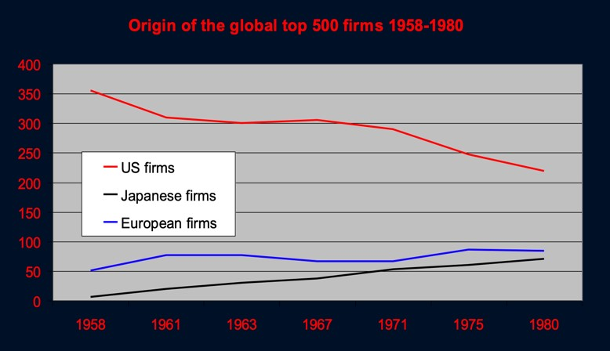
US is losing some company in the top 500.

Japan is gaining some.

This indicator is showing a rebalancing.

Japan’s arrival as a competitor: (high range of products)
- Catching up technologically with Europe in many sectors (electronics, cars): thanks to the policy of Window guidance = industrial policy by Japan government to help other national companies to produce better, in their organization, ...
- Becoming a high-tech exporter
- The brought the differentiation of products

Industrial Revolution III (1969) : Automation computers and electronics

Rise of emerging economies
Newly industrialised countries in East-Asia, in Latin-America and East-Europe
- Large-scale standardized production based on labour-intensive activities (learned from Ford)
- Able to produce the same as Europe but at better prices: flexible cost in the 4 tigers are lower (energy, RM, taxation, and labor) ® Cheap and skills
- Started to get into technology

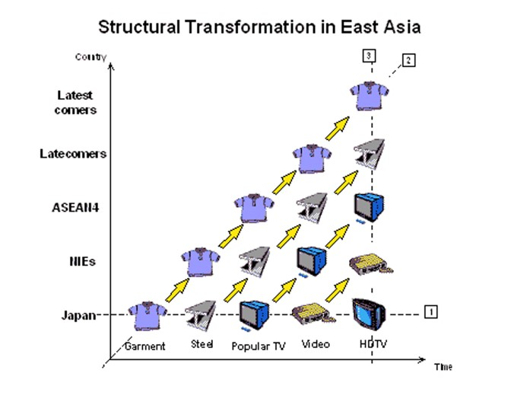
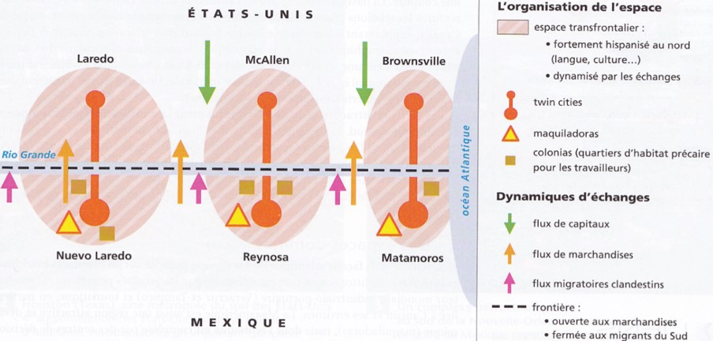
Developed in all Asian countries : With the development of Japan: each time a country can reach a higher level of production, they let the low cost/low level technology to other countries (outsourcing), and step by step all countries will increase their place on the international market and improved their technologies

One leading country (Japan) and following countries

US reaction to the rise of competition
- Strategic Defence Initiative – SDI, also called Star Wars’ programme from 1981 onwards
- Tremendous upsurge in military expenditure as an indirect industrial policy for high-tech industries (1981-1993).

1.4. Shift towards post-Fordist production process

Because the competition was rising, they needed to change strategy and get out of Fordism.

RAPPEL: Fordism: to produce you need to design and manufacture. In Fordism, everything is located in one company. Economie of scale, mass production, mass consumption. Ford produced in Detroit, everything is centralized. Corporation is fully integrated, and you export. You export what has been produced in a central place. Red lights are when you cross borders. You create a subsidiary but it’s fully resembling, so you switch in other country if the area is too far away.

The new production process:

- Product differentiation (primary developed by Japanese companies):
Firms differentiate through two main strategies:
  - Supplying of higher technological content (computers, software) & moving upmarket. So, they’re upgrading their product by putting more technology in
  - Multiplication of models to fill in the various niches on the market (consumer preferences, branding, design, packaging, etc.). To satisfy the entire demand (coca normal, light,)

NOTE: Product differentiation is an idea of stronger market.
But the idea of internationalization ins negative for costs. + if there is a problem in 1 model, then we must adapt everything and being flexible (volatility of demand)

- Switch to lean production (prevent or avoid any waste)
= Reducing costs, time needed for production, increase the quality
= a way to have a quick feed-back and then quick reaction of company

  - Geographical proximity of the production units to ensure feed-back and quick reaction to changes in consumer preferences and to changes in aggregate demand
  - Smaller and more flexible production units and/or computerized multi-product production units (just-in time, almost no stock)

- Rise in fixed costs (sunk costs):
  - Investment in new products: R&D, design, marketing & advertising.
  - Investment of production processes: robotics, software, tailor-made specialized machinery.
  - Growing firm optimal size.

- Increasing regionalization of production processes (RPP):
  - Slicing up of the value chain between different location sites
  - Regional supply chains and regional value chains (to be distinguished from GVCs);

1.5. Substantial impact on the European integration process

- A global production process to serve the world demand is often too rigid (transport distances, consumer proximity)
- A national production process to serve a single national market does not allow to benefit from the economies of scale
- Many firms regionalize their production process according to the comparative advantages of the national economies (cheap labour, highly skilled labour, rare inputs, business clusters, fiscal policies) to serve a regional market
- Strong lobbying from MNEs located in Europe in favour of the liberalisation of intra-European trade and investment flows.

2. The acceleration of the EU integration process

2.1. Big business lobbying campaign to remove intra-EU barriers

Lobbying is a subtle manipulative method of a specific group to obtain decisions that go in the direction of its interests by using its power and influence.
Lobbying is not necessarily European companies (Huawei, …) Lobbying is in different country over the world, not only in Europe.

Creation in 1983 of the European Roundtable of Industrialists – ERT Composed of 45 companies such as Krupp, Phillips, Total, etc.
Lobby for implementing a real single market without trade and investment barriers.
- To best way to gain money is to relocate in Europe. How? By freedom of worker movements and freedom of investment.
Why? Because they understood the limits the national strategy (no ability to compete with the US)
Transform the common market into single market
(know the difference! Steps from the common to signle market ) Removal of the TBT à
Implementation od the Single market à Suppression of physical barriersàbetter integration of transport systemàMaastricht treaty (€)à Stricter control of national subsidiesàPrivatization of National companies.

- Make it more integrated

Most of the member states maintain the integration progress
- Germany: they were the most competitive in all sectors in Europe (they didn’t fear foreign firms). So, they wanted to be involved with western and eastern part. They needed the single market to benefit from competitive advantages of others.
- The UK: wants to export British competitive services such as finances. They attracted the most in term of investment and had developed national champions. They want single market only in some specific sectors. For the rest, they prefer to stay more protectionist
- Benelux, Ireland, Denmark: too small to survive without the integration
- France & Italy: although reluctant, must prepare EU integration.

2.2. Dismantling of technical barriers to trade

Technical standards exist to protect the consumers, but the problem is Europe is that these technical standards were used to protect the national industries instead.

The cassis in Dijon case (1979)
Rowe-Zentral AG, a German importing and exporting company, attempted to market the French blackcurrant liquor “Crème de Cassis de Dijon” in its home country. (French were exporting to Germany)
To allow Alcohol to enter in the country, you need a minimum imposed. However, in Germany required minimum content for alcohol is 25% while the French crème was only 15-20%. France can’t enter Germany because it’s too low. Germany wanted to protect their people from
France. (If too low, it can cause addiction.)
First step (and biggest) to reduce the Technical Obstacles : the German importing company took the case to the European Court of Justice.
Verdict: Germany sentenced for illegally banning French liqueur. (??)
Principle of MUTUAL RECOGNITION of national standards between EEC Member States alleged by the court (= all barriers fall except if you’ve got a real good reason to keep the barriers).
So, Germany must respect the law of France and vice versa.
If Germany respects their own rules, France can’t decline. (Members of EEC has to respect the national rules of the national product)
No common rules, just a recognition of the country’s rules!
Too many barriers are remaining in Europe
Some companies suffering about the local restrictions (like percentage of alcohol here)
Other countries need to accept the standards of France but it’s the same for France, they need to also accept the standards of other countries like Germany - Nobody complain about it
A national standard can’t stop a company, if they really want to have access to German market There is a problem because Cassis of Dijon is a liquor and not a wine, but they can’t change their product

Directive 83/189
Additional step for having a control, double control
Making of national technical regulations submitted to the control of other Member States and the European Commission, which can intervene in the national legislative process in order to prevent the creation of new technical barriers inside the European Common Market.
Became rigorously enforced after 1989 and completely accepted by the end of the 1990’s.

Harmonization process required and led by the European Commission For health and consumer protection norms.

It’s better to buy European product because it’s safer than American products, for example (we know what there is in our local product)
Example: They used hormones for chicken but now there is restrictions about quantity of this chemical product

To this end, establishment of:
- CEN (European Committee for standardization) & CENELEC (European Committed and electro- technical standardization) located in Brussels
- European medicines agency based in London, UK
- ETSI- European Telecommunications standards Institute based in Sophia-Antipolis fr

Advantages for producers
- Reduces compliance costs
- Increases scale economies
- Creates interoperability/compatibility
- Disseminates know how
- Induces International commercial policy: first mover advantage

Advantages for consumers
- Decreases uncertainty
- Facilitates comparison

2.3. Implementation of the European Single market

There has been 30 years without any new treaties. How come?
Europe has become pessimist (no one believe we could move further).
Transforming common to single market.
Green Paper: doc by EU commission and able to give opinion on that. On specific topic. (Consultative process)
White Paper: Actions. With project that we have to launch

1985: Jacques Delors & Lord Cockfield’s White Paper
Aims at removing all obstacles to the four freedoms of movement inside the European common market (commodities, services, labour force and capital) ð Developed the common defense policy + wanted a more integrated market. ð 300 recommendations to create a single market instead of a common market.

1987: Single Market Act
Within the Single European Act, major institutional reform:
- Adoption of the Qualified majority voting system at the European Council level : meaning that 72% of Member States need to be representing 65 % of the EU population. If the 65% are not reached, you need a revote.
Today that’s 260 votes out of 352 in the European Council.
- Blocking minority of 4 members.
- Unanimity voting remains for taxation, social security, accession of new members, foreign and defence policies.

2.4. Removal of physical barriers

- Physical borders refer to customs and immigration posts at border crossings: border posts impeded the movements of people (due to passport controls) and goods (due to delays for inspection & custom formalities);
- Removal of border controls with the implementation of the SCHENGEN agreement from 1995; Schengen agreement : Makes the physical borders dissapear, reduces formalities at the borders, reduces the time you spend at the airport.
Schengen agreement are from the same single market; the other don’t belong to the same market but are a part of the agreement. So some countries are part of the agreement even though they’re not from the EU.
Some are waiting to join the Schengen area (even though they’re a part of the EU)
Why? You need to have your borders controlled, if you cannot trust the other countries, security wise it can be dangerous, if they give access to Bulgaria etc they can try to find a better life and job in a richer country.
Ireland wanted to be a part of the EU but not of the Schengen area.
- Significant time gains for intra-European trade as half of it was crossing at least two borders.

2.5. Better integration of European transport

- In 1992, The Maastricht Treaty in gives the Commission powers in the field of transport integration with an annual budget of €300 millions.
  - Increase strategic transport connections between member states : the tunnel between the UK and the continent was partly paid by the EU, the thalis between BX and Paris
  - France gives capital to the EU but without getting something back, that money is going to be used for projects in other EU countries.
The Maastricht treaty launches the implementation of a single currency to be due at the end of 1999 : the €. There was officially a single market.
- Road transport integrates at the European level, European authorisation replace national authorisations: 68% of the tons of freight per kilometre are carried by trucks in 1990 and 76% in 2000).

2.6. Stricter supernational control of state subsidies

- Stronger enforcement of articles 90, 92 and 93 of the Treaty of Rome by the Commission: stricter procedures implemented to check Member States’ subsidies
- In 1990 the Commission officially confirmed by the Council in its role of controller of Member States subsidies
- Six times more inquiries launched by the Commission in the early 1980s than in the 1970s. Negative decisions increase six fold
- Result in a great lowering of state subsidies: the share of national state aid in the added value of the manufacturing sector reduced by 50% between the mid-1980s and the late 90s.

2.7. Privatization of national champions

Until now, we saw the integration steps: harmonization, single market , Schengen , euro currency implementation, subsidies related to national champions strategy (to make them stronger on the EU markets) have gone down. To finish with the acceleration process, what is happening now at the business level following these steps.

Until 1980’s a lot of companies were linked to the state (owning some shares, subsidies, etc..). But now, people want to privatize. We’re showing that a lot of company got privatize to make the
competition easier because there is no more state intervention. (??) The privatization starts in:
- UK, with company related to utilities (water, gas, electricity)
- Germany: Volkswagen goes privatized, VEBA (chemicals).
The post and telecoms become privatize so they get a ‘fare’ competition and get into the European market.
- France: much more company in France are control by the state because they feel that they don’t have enough competition.
- Italy

What are the impacts of that privatizations?
Suddenly more mergers and acquisitions in Europe.

2.8. Larger merger wave of European history starting in 1986
Companies acquired freedom by becoming privatized : they could invest and acquire other companies.
Example: to set up subsidiaries in another country. Let’s say there is a foreign company that is well situated (low labor cost) with good technology. Well, you can target it and merge with it or acquire it.

These mergers and acquisitions are taking place in industries with a lot of fixed cost (not really in other sectors):
- a lot of R&D, you don’t have a product yet or consumer so it can be heavy and a lot of FC
ð computer, machine tools, chemicals, transport
- marketing: you are marketizing a product, and if you want your product to stand out, then your product needs to be identified by your consumer
ð food, drinks, tobacco …
• Combination of both R&D and marketing
ð Cars, household appliance, pharmaceutical, cosmetic, …

3. The wave of M&A impact (1986 – 2001)

Merger: both partners agree. Even if it’s friendly, you need to see who has more shares in the end in the merger.
Acquirement: there is one company taking power to the other.

Who’s buying who?
The company that are acquiring (Germany, Fr, UK, bit in Italy) tend to buy companies in smaller and less thriving economies (neighboring countries). Because they are bigger and get national economy of scale, it makes them more competitive to smaller economies so smaller markets that don’t benefit of economy of scale. So weaker country invests less in foreign countries.

Exception: Finland, Sweden, and the Netherlands
They’re in a smaller market but they are among the countries that have competitive companies and that investing abroad... how come?
They know they have de disadvantage of having a small market, and they couldn’t get that economy of scale. So they decided to go with another strategy: differentiate themselves from other by being on top of innovation.
They invest a lot on education to have more skills on their market. With more skills, you can innovate (policies to develop the skills).
Sure, with time, other countries will adapt and use that technology, but you’ll be the first and you’ll ba able to get market shares at the European level thanks to you monopolistic position (temporary) Example: Ikea, Swedish company. It’s in Sweden because they’re specialized in timber raw material (wood)
The single market price isn’t good: you have winners and losers

Some sectors stay national (no privatization)
You’ve got some interesting industry with a lot of FC but no M&A, but why do they keep the national champions strategy (no integration) :
- Defense industries: national security.
- Utilities: Electrabel is French. France can put pressure if any problem occurs with Belgium. Same goes with banks
- Pharmaceuticals: it’s a global value chain but the states want to keep in nationally owned in case of a pandemic. In that case, you can guarantee that the national demand is fulfilled before exporting it (D > O).

In the US, they developed GPS and drones were used by the military. Only later did it become public. Some sectors can have dual use: the special use for the industry and other uses.
In pharmaceuticals, we discover chemicals. Later, in some cases you realize you can use in medicines but also in chemicals in paintings or isolation, cosmetics, so if you have pharma industry you have solution for chemicals, cosmetic etc. and not only your field.

In 2001, all the possible mergers are done, and less people is interested in buying.
In 2002, rebalancing is happening: some European companies have caught up the US and joined the top 100 (chemicals, auto, machine tools, construction, telecom, food and drinks) From 2005, only when eastern country joined, the M&A came back.

European aeronautic defence space
A European champion was created in 2000. It’s a merger between European companies to develop the aeronautic sector. The countries are France, Germany, Spain + UK collaboration.
It was important to create a European champion in aeronautic because Boeing (USA) was dominating the market. So, the Europeans were depending on American to travel. They decided to create from scratch an European company: Airbus.
It’s not easy because it’s a small market (100 planes/year). But Boeing and Airbus need to sell each 100 to cover their fixed costs (equipment, tools, skills,), that means they would need to whole market for themselves to be able to survive. That’s why Boeing is highly subsidies by US and same for Airbus from EU subsidies.

Car production
BMW in 2008, doesn’t have as much relocation as others why?
They sell luxurious cars; they’re not searching for low cost. The want de “made in Germany” tag.

Stellantis: only way that Peugeot can go up VW, in terms of volume of production.

In 2004, 12 eastern countries were integrated, which was bad for car production in Spain. They lost part of the production process of cars because of the relocation of the factories in Eastern Europe.
It made a movement of jobs, income and profits
• The car production is relocating in East by M&A of factories

Module 5: Three structural issues of the EU integration process

1. External Economy of scale

1.1. Definition

Economy of scale or Marshall districts or Business clusters are a gathering of some companies in some geographical area and use each other’s advantages, that are in the same industry (same specialization)
- Scale advantage gained at the industry level and not at the company level
- Geographical agglomeration of companies with a sectoral specialisation

They are reached through spillovers and linkage between companies:
- Pool of suppliers: (raw materials and components)
- Pool of labour force (attraction of qualified labour, synergy with universities and research centres)
- Knowledge spillovers (best practices, innovation development, business intelligence).

If you have economy of scale and have pools (of labor, suppliers, and knowledge) then the area is going to get wealthier and increase the concentration of activities. People will be attracted by the area, but the surroundings will get less popular.

Business clusters occur in many different shapes and forms
- Around large anchor companies that have over time attracted a network of suppliers and service providers (Toulouse aerospace valley)
- Ground of small- and medium-sized companies that have been able to overcome the disadvantages of small individual size through active collaboration
- Small start-up companies that have developed around a university or a research institute (Silicon Valley as an example)

1.2. Business clusters in US

Example: Silicon Valley (technology).
There is economy of scale happening because of their closeness. How?
- Reduced HR cost: a big cost for a company is that search for skilled people (HR cost). So, if you are situated next to a university that has a good IT (California and Berkley University), then spotting the right skilled people becomes easier.
But beyond the University level, you can find the skills needed from the company next door as well.
- That’s call the brain drain: if you have IT skills you go to Silicon Valley
- In the area, informal circulation of knowledge is quicker
- You can share factory: same RM and you can have bulk order and have economy of scale. In case of small companies, the cost is high, so this economy of scale is a real advantage. Also, a series of small companies can get together and share costs like assistance, offices, etc.
- In LLN, there is a special center with common offices with common assistance (external economy of scale because you share and collab because of the closeness)

1.3. Business clusters in Europe

Clustering of key industries in Europe:
- Concentration and polarization of industrial operations: not a fair distribution of value created
- Issue of value distribution in Europe in regional value chains
- Issue of income distribution between Member States, depending on your specialization

Building a Silicon Valley in Europe will need lots of strength because of there is a severe competition with them: they propose better pay and better opportunities.
• Not specialized in high tec but in lower tec (the assembly)

Redistribution process
Clusters and specialization of companies in country creates social and economic differences. How do you manage differences (>< convergence) between countries: by taxing the wealthy and specialized companies = redistribution
In Europe, we pay our taxes to national member state: 99% is used it for national economy (national redistribution) and 1% goes to the EU GDP and is redistributed to the whole of EU to rebalance the single market.
The problem is that some country receives more after redistribution then what they gave (1%) in the first place. So, there is a gap.
Portugal and Poland are gaining more than what they put in.

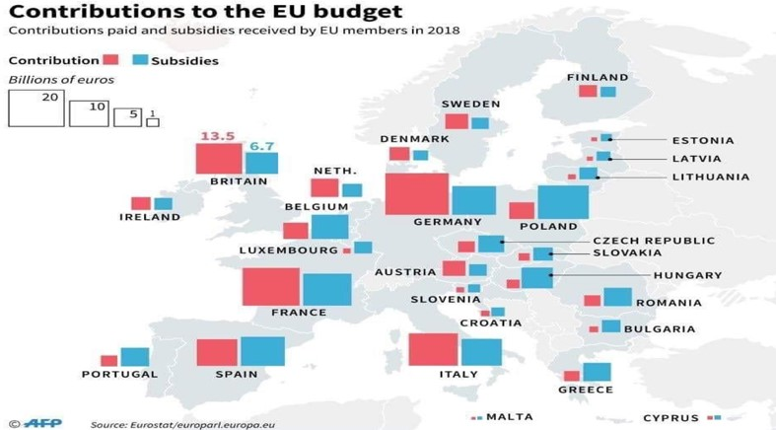

Why other countries aren’t complaining?
Let’s take German companies based in Hungary, then the German companies are benefiting from that redistribution as well, even though it’s redistributed to Hungary.

But Greece. Nice holiday, not too expensive but you won’t put your factories there because of the lack of skills. So, Greece is good for tourism and farmer products, even if they offer good taxes (fiscal heaven)
And tourism isn’t the same thing as producing.

The European budget
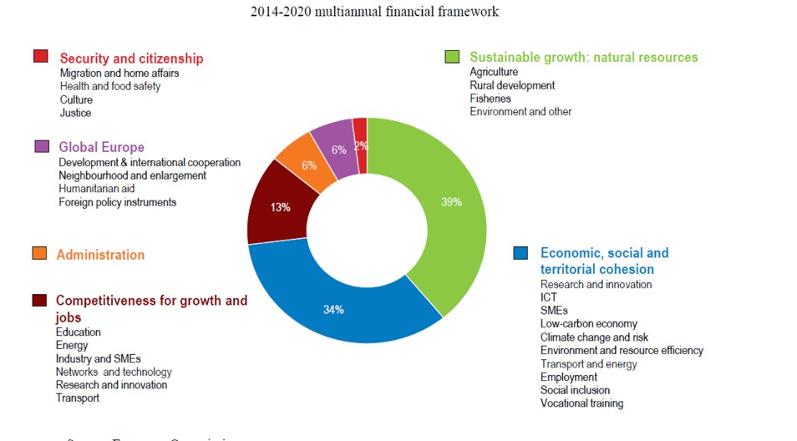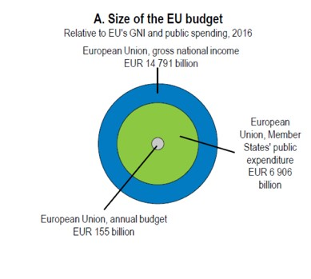
Blue
circle: all the value being creating in one year at EU level

M
iddl
e circle
:
public
spendings by member states such as

public
budget dedicated to financing studies, infrastructures, help companies
etc.
These are spent thank to
taxation.

Grey circle: what goes to the EU to be redistributed

Let’s say you’re a worker with 1000€ revenue ® 50% goes to taxes: 500€. From those 500€: 99% goes to the government and 1% goes to EU

Example:
There is a cluster of aerospace in France. That means that a Bulgarian skills company is going to move to France to be in that clusters (pool of suppliers, skills, and knowledge). Once that company is based in France, they’re going to finance France’s activity. So, Bulgari loses activity and will stay with companies that can’t move out. It creates disparities: less revenue to finance the activity (vicious circle)

2. Is the Euro an optimal currency for the whole Europe?

There are two types of currency:
- fluctuating currency: depends on the demand of the currency, value of the currency changes
- fixed exchange rate. For example, FCFA fixed rate with one euro, so the value doesn’t change

The demand of a currency is made by locals and investors. But if it’s getting higher demand for you, that means there is low demand for another: people are exchanging their currencies for yours. => you don’t fluctuate alone.
Why investors?
A high interest rate will push the currency up: the foreign investor is going to have interest in that currency because by putting it in the bank, he’s going to get revenue out if it. Therefore, more investors are going to come in to get that access.
But there are limits into attracting people with nice interest rates. For example, even if Russia decides to increase his interest rate, nobody will have an interest to get access to that money, because of the political situation.
- So, euro value depends on local economy comparing to the rest of the world (how many investors are coming in or out)

The trade balance is the main indicator that counts what’s coming In and Out:
balance of payments = trade + capital account+ financial account + aides + migro-economy The trade balance is important for the currency. If you export more, then people are going to need your currency to buy your goods.
- If trade deficit: it means you export less, the demand for your local currency is low, the value decreases. It can go up if you have innovation or new products
- If trade balance is positive: it means you’re exporting, the demand is high for your currency, the value increases. For the rest of the world, accessing your country is going to be expensive.

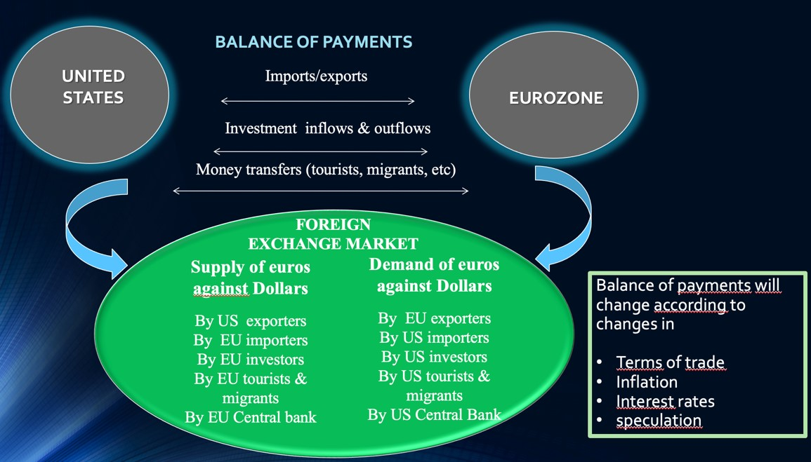

2.1. Functioning of the euro

- What does determine the value of the Euro: the balance of payments between the European Union and the rest of the world
- The Euro: relatively strong currency
- The Euro: a free-floating exchange rate regime

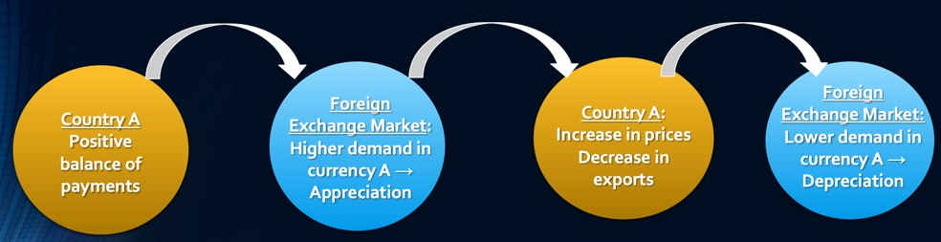

Why, after the positive stage there is a downstage/rebalance?

The products will become more expensive, wages as well, to travel in that country will be more expensive, etc. The fact that the currency is appreciated (the prices become high for the rest of the world) so there will be a rebalancing between what is happening in terms of exchanges and the currency, then till become positive again, and so one ... it’s like a wave. As a local citizen you don’t see the high prices when your currency appreciates
• Advantage: if you go to the USA for example, you can buy more dollars.
- Disadvantage: your prices will not be attractive, you lose price competitiveness because you’ll be too expensive for other companies in other countries,
But for some countries/industries a strong currency is not a problem: basic products with low supply like oil & gas no matter the price people need those products, luxury industry = out of price competitiveness.
- Advantage: attractive for financial investors that want to buy the strong currency (speculators)

Link with Europe
Let’s take two countries with € : Germany and Greece
- Germany: Balance of payment is positive cause they export more than they import, lot of machine tools for the rest of EU, cars industry
- Greece: Negative balance of payment because they import more than they export (more money is going out than in). There is a lot of tourism, olive oil, feta cheese, maritime transport, …

How is the € in this situation?
The Euro is reflecting Germany and Greece. If the euro were only in Germany, then It would be high but if only in Greece, then low. So, with both sharing a same currency, it’s in the middle.
These two countries’ attractiveness is based on different things
- Germany: out of price competitiveness. If the prices go up, there’re not going to loose consumers, their competitiveness is more into quality, technology, etc…
- Greece: price competitiveness. Greece attractiveness is based on low prices. It’s not luxurious. Germany would be okay with a high currency while Greece wants to keep that currency weak.
ð This means that every country depends on the economic situation of other countries, interdependency is not good for all countries (like Greece) : if greece didn’t share the € they would be even more attractive with the prices cause without Germany the € would be way weaker so Greece would export more and could rebalance its balance of payment .

Why Germany stays with Euro?
For Germany it is an advantage that they share € with Greece because they stay attractive because they stay relatively low than if they wouldn’t share. So, it makes German products cheaper to the rest of the world. Thanks to that Germany can export more.
When they buy oil and gas from Russia, they have the purchasing power to buy it cause the currency is strong. If the currency becomes weaker (like the Greek want) than those products would become more expensive.
It makes Greece lose price competitiveness in the process.

2.2. Weak or strong currency? What is best?

a. Advantages and drawbacks of a weak currency
- A weak currency makes the domestic products more competitive against foreign goods
- A weak currency fits economies based on production of goods and services needing pricecompetitiveness
- Policy of competitive devaluations = aims at under-evaluating the national currency to gain competitiveness
- A weak currency is a currency with a weak purchasing power abroad:
Problem when transnational production process and economic interdependence.
- A weak currency does not necessarily make the domestic economy stronger in the longer run: no search for economies of scale and productivity gains by national companies.

b. Advantages and drawbacks of a strong currency

- A strong currency makes the domestic products less competitive on the foreign markets.
- A strong currency can force the domestic firms towards internal devaluation also called competitive disinflation = competitive prices:
  - economies of scale, productivity gains, efficiency improvements, etc.
  - Results only in the middle and long-terms.
  - A strong currency can force the domestic firms towards innovation and high-tech products
- A strong currency fits economies based on production of goods and services based on out-of-price competitiveness.
  - A strong currency is a currency with a strong purchasing power abroad.
- Makes access for a cheaper RM

2.3. No synchronized business cycles between the Eurozone

Export patterns between the European Union
- CAPITAL GOODS or producer goods: designate means of production or products other goods and services. Capital goods include factories, machinery, tools, equipment, and various buildings which are used to produce other products for consumption
- CONSUMER GOODS: products directly purchased by consumers for personal or household use.

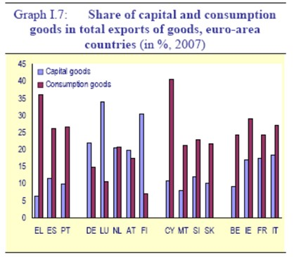
If capital goods>consumption: no currency competitiveness, out of price competitive
If capital goods < consumption: need currency competitiveness

More Red : those countries need a weaker currency
More Blue : those countries are less sensitive to the value of the currency

Evolution of Member states’ current accounts since 1991

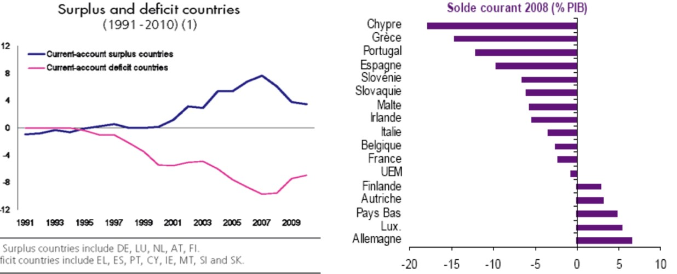

€ came in 1999 : The surplus countries increase their surplus, pink countries strated with a currency that was already weak so € made them even weaker cause it’s a too strong currency.

« En quoi les déficits courants posent-ils un problème en Union monétaire »
Same currency on the Eurozone single market and same exchange rate Euro/Rest of the world for every Eurozone Member;

But important differentiation in production processes and specialisation:
- Some national production systems rather based on price competitiveness: EL, ES, PT, FR, IT, etc;
- Some other economies on non-price competitiveness (quality differentiation, innovation, inelastic demand): DE, FI, NL, AT, etc;

How to reach price competitiveness?
- Competitive devaluation is not possible any longer within the euro area;
- Can only be reached through reduction in labour costs (wages, social charges) and further labour flexibility (relaxing of work contract & working time);

3. National fiscal policies and transfer or pricing strategies

3.1. Transfer pricing in Europe

Transfer pricing: price you sell components or products within a company.
ð if you want to sell within the company, you’re not on the market since it’s an internal transaction. But even if the transaction is to your own the company you are obligated to sell. But you don’t have to sell it at the market price (in other words, not the price you would sell to an external consumer) but it can’t be too far from that.
At the end, it's like an import-export operation but within the same group and without the hassle of international and border crossing transactions.

Let’s take this case in a single market:
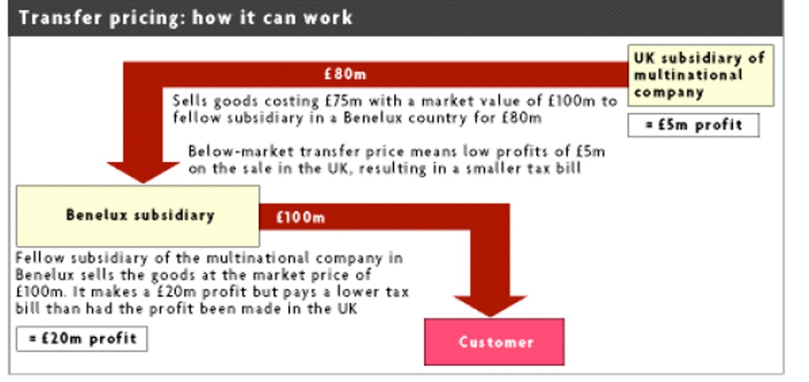
(Creating externalities in the UK)
The company has 2 subsidiaries: in UK and Benelux.
First scenario:
 | Cost | Selling price | Margin
UK selling externally | 75M | 100M | 25M + higher taxes!

Second scenario:
 | Cost | Selling price | Margin
UK selling internally | 75M | 80M | 5M
Benelux selling externally | 80 | 100M | 20M + lower taxes!

Before Brexit, UK didn’t pay capital movements (less custom duty etc.) But now, there are barriers. There is a problem: how can UK redistribute? Here the transfer of goods is only made to avoid taxation of UK but selling it in Belgium means that it enters Belgium’s treasury and not UK’s.

Transfer pricing is a normal process, the question is if you do it to really transfer (for SCM purposes) or to pay less taxes.
- Positive impact: you create jobs
- Negative impact: bad production process, creating traffic, can impact real-estate, need to provide infrastructure for the creation of the goods but you also have to make sure that everyone around the company has a house,...
Concern from tax authorities: the state needs to ensure that in making these transfers, these groups do not evade taxes and that there is no bad competition.
To ensure that the tax bases in each country are as fair as possible, to avoid conflicts between different tax administrations and distortions of competition between companies, OECD member countries have adopted the "arm's length price" principle for intra-group transactions. This means that the price charged between dependent enterprises must be the same as the price that would have been charged in the market between two independent enterprises.

Apple case:
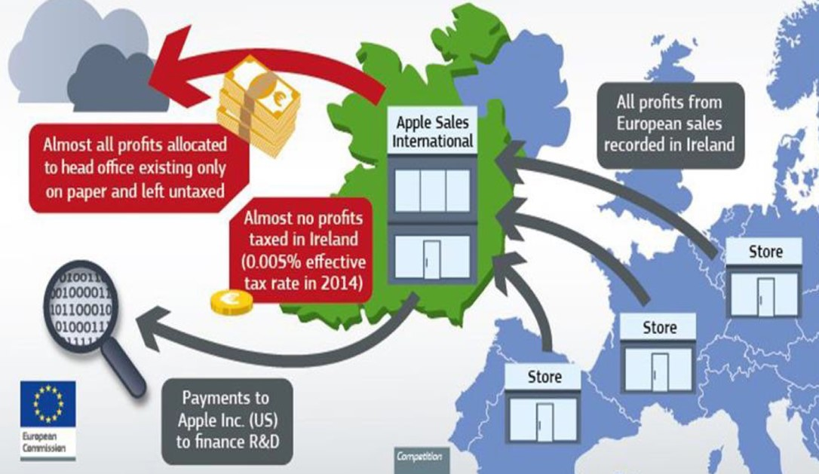

There is apple store everywhere in Europe, but all the profit are declared in Ireland (taxes low).

How did Apple install rich ghosts in Ireland? Because Ireland turned a blind eye to an elaborate tax optimisation scheme that was highly profitable for Apple! Indeed, it allowed the computer giant to pay as little tax as possible on European soil, in four simple steps:
- Becoming (somewhat) Irish
In Ireland, Apple created two entities: "Apple Sales International", which sells the group's products in Europe but also in Africa, the Middle East and India, and "Apple Operations Europe", which manufactures certain ranges of computers, a much less important activity. Both companies have the right to distribute Apple products through an agreement with the American parent company. These two companies give money to Apple, 2 billion euros per year (deductible) to support the group's research and development.
- Repatriate the money collected in Ireland
All profits made in Europe are recorded in Ireland. You can buy your iPhone, your Apple Watch or your iPad in Paris, Limoges, Berlin or Barcelona, the result is the same: it is as if you had bought it directly in a shop in Dublin.
- Artificially distributing these profits
Internally, all this money is distributed in a totally artificial way. A small part will be accounted for in the Irish part of each of the two entities. This money is then subject to corporate tax, i.e. 12.5%. This is already one of the lowest rates in the European Union.
- Profit
The rest of the profits are not considered "Irish" and will be redirected to a hypothetical
"headquarters" outside the country. The Irish state believes that it does not need to know where this money is going, as long as it has been able to deduct tax on part of the profits. The European Commission has found almost no trace of real activity at the two 'ghost' headquarters: no specific employees, no premises, no possibility of carrying out any concrete activity.
In 2011, Apple paid only 0.05% tax on its total annual profits. In 2014, this figure was even lowered to 0.005%.
Ireland is also benefiting: last July, it announced a staggering 26.3% growth for 2015, almost four times higher than its initial (already impressive) forecast of 7.8%. In France, it was 1.1% over the same period.

Tax optimisation or financial engineering accounts for around 38% of worldwide FDI (31% in 2010) – $15 Tn

Doing this game is easier when you’re in services because they are much easier to transfer: you buy your smartphone but in that price there are apps and software and this is intangible, there is no physical so it’s much easier to state that it doesn’t come from the store but Ireland.

There is limited political integration. France is losing revenue to Ireland. They need fiscal revenues, and they know you’re using transfer pricing. What is the power of France? They can’t go check themselves, so they must ask the Irish government to check.

3.2. Transfer pricing from Europe and beyond

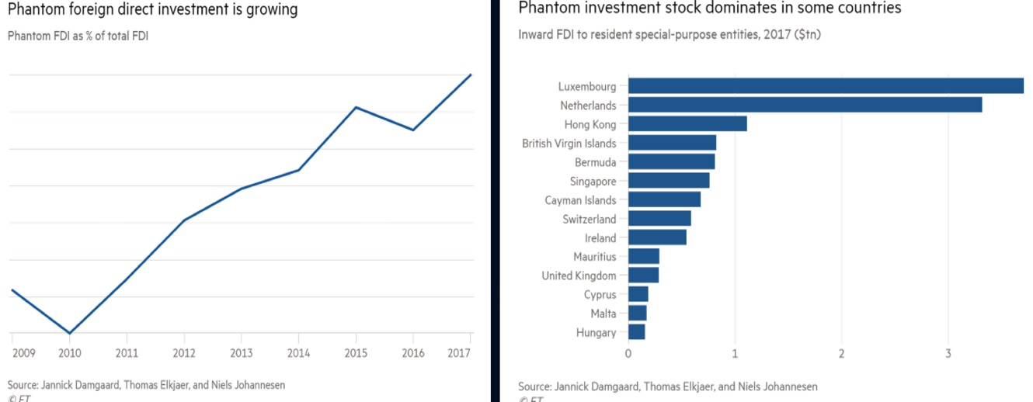

Clearly, the manipulation of transfer prices has exploded since 2010. No wonder Luxembourg is at the top of the list of countries where the most ghost companies are created.

The commonwealth: when money is transferred from London to Caylman Island is like it’s the same country. That’s what we call the laundromat (Money flow is free in commonwealth.)
Bad news from Brexit: you can’t send to London then to island so loosing easy access to laundromat.

Module 6: The EU today: facing renewed and challenging competition. (2000 – Present)
Top 500 firms 2001-2011 : US / EU / Japan /China. European firms caught up with US firms (in term of competitiveness) + new competition from emerging countries. (china = new comer)

1. EU firms VS US and China

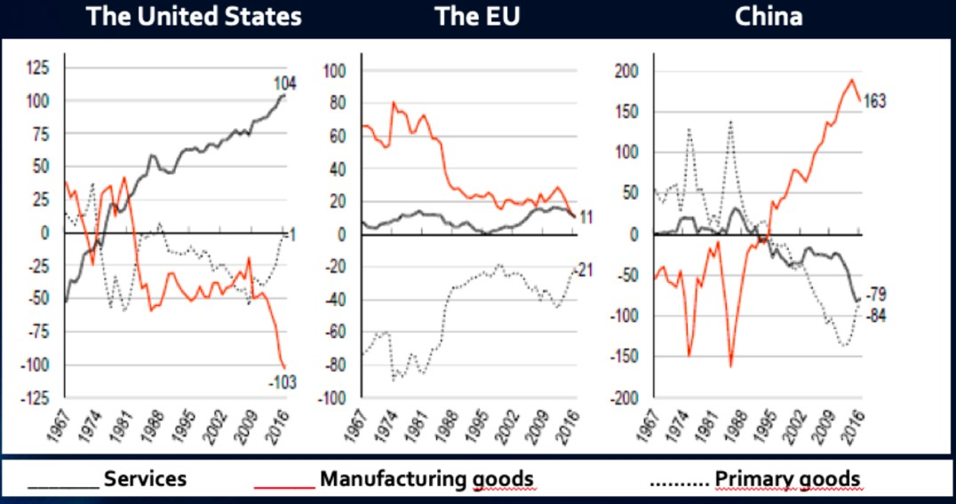

Sandwich : shows what they’re good at exporting
The EU is importing more primary goods than export
USA had a strong dependency in raw materials, they have been improving their situation for raw materials.
Levels of export have been diminishing, lost market shares abroad
China depends more and more on primary goods, big deficit in manufacturing goods
They have improved their exports of manufacturing goods
EU is losing and China is gaining
USA is improving their services à IT services (cfr. starwars program, drones,military...) SANDWISH: You got the EU in the middle and are under pressure from China (manufacturing goods) and USA (services) à EU is stuck in the middle and doesn’t know what to do.
Why does USA import less raw materials? àlocally they decided to exploit Schell gas and oil.... Ils ont investi dans le gaz et pétrole de chiste car dans le pays où ils importaient c’était risqué a cause des guerres/terrorisme au moyen orient... mais c’est hyper polluant et demande bcp d’eau.

- Chinese and EU competitiveness in manufacturing chains

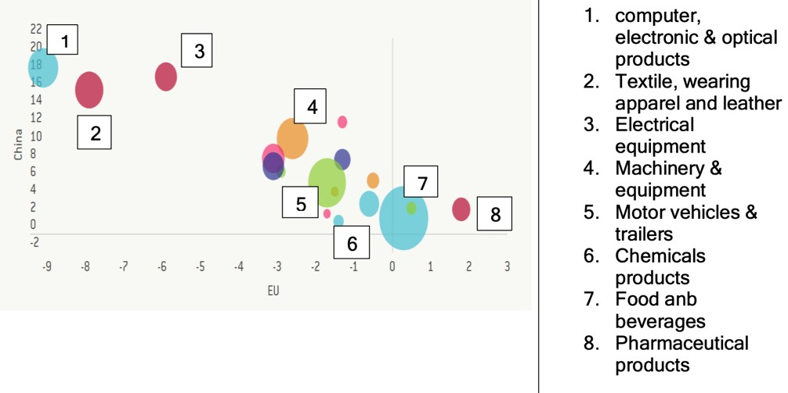
Illustration of sandwish
How much chinese companies contribute to the production for manufacturing products And same fior EU . EU is losing a lot and china gains a lot

- EU countries are net importers of US digital services

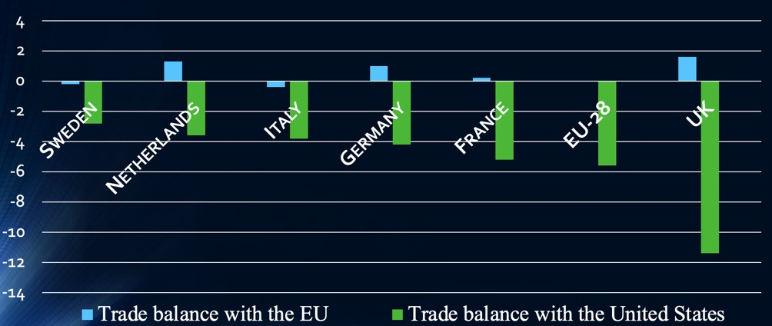
Most economies in the EU are importersànet importers and they do not export to the rest of the worldànet dependency vis-à-vis digital servicies from outside
Digital service = softwares (IOS, Androïde,...), services to store data (cloud service), `

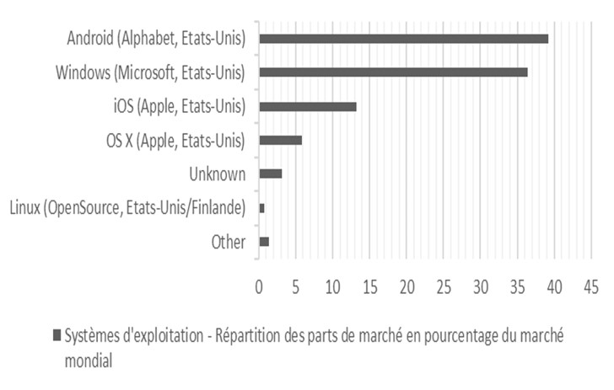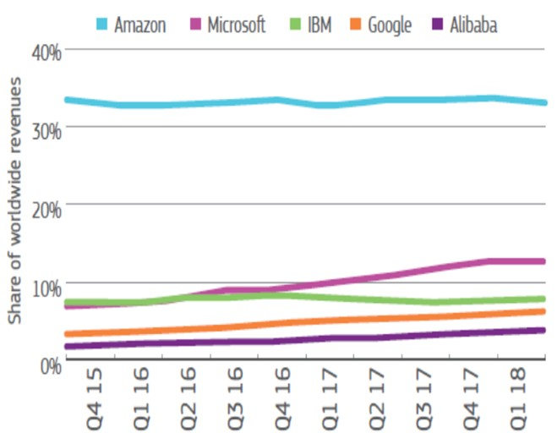
No EU services in the graphs. EU software : OVH = 1% of the global market

c. Intensity of the robot use in different countries in 2000-2020

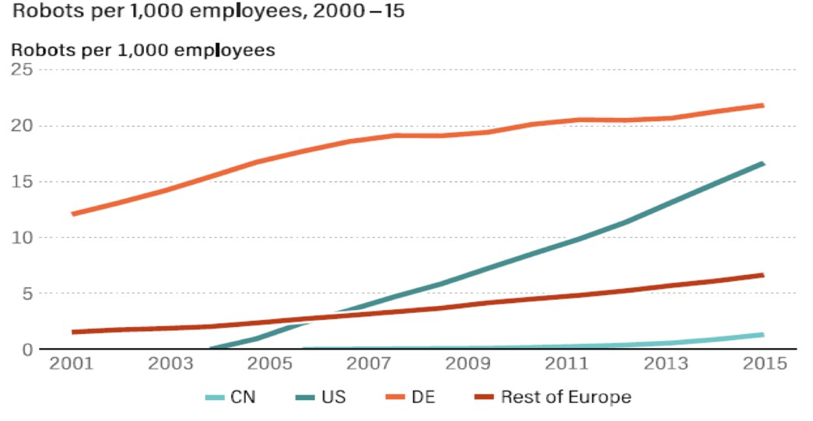
You design the product (ipr) and sel that --> the buyer creates the robot with the help of the design. Europe is the best in terms of robots but there is the USA that’s increasing and catching up

2. Implementation of Wintelism and Modular Production Network

Wintelism, derived from Windows (operating systems of Microsoft) and Intel (PC’s microprocessors)
Another explanation of the gap Wintelism = Interntional Production Networks New production process developed in high tech industries:
- New vision of the industry’ s value chain
- Wintelism argues that market competitiveness has shifted away from manufacturing costs and essentially derives from intellectual property and monopolistic innovation capabilities
- High tech companies concentrates on upstream R&D activities and downstream branding & marketing activities
- Full production outsourcing (especially towards China, India, Taiwan): To control the technology enables to hold greater bargaining power while contracting out the production process to independent producers and therefore to dictate production costs to suppliers and subcontractors
- International production networks management
- To be competitive, we have to be innovative

From a fordist-type corporation: vertically-integrating the whole value-chain in the same location…

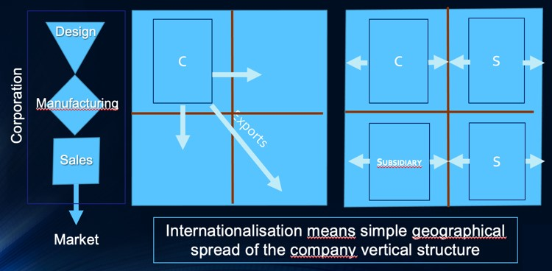
= Fordism (mass production, mass consumption, ...)
Doing econmies of scale by producing localy, Only 2-3 models Subsidiary looks exactly like the headquarters, everything is intergrated in the company
Vertical : in one location, all the steps and value chain is produce in the same company
based in Detroit . you control most SC process

…To a Japanese-type corporation, vertically integrated with a lot of suppliers (subsidiaries or subcontractors) abroad
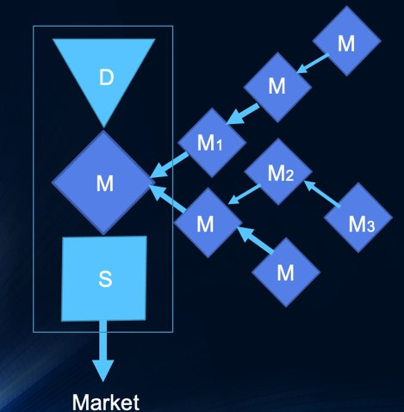
- Regionalization of the production process (through outsourcing and offshoring): to reduce your cost, you outsource/relocate a part of your SC, then part of the production is getting more regionalized and not internalization fully, to not go too far away, easier management, etc. you keep control even if it’s outside, you have subsidiaries
- Lean production
- Differentiation: price and quality
- Rise FC : marketing, etc. so you outsource for cheaper labor, RM,etc.
- Political boundaries to cross over
- With differences in national regulations
- From Japan to East Asia to the world
Post fordism ? The assambly might be done in another country

Towards a modular network form of company in high tech sectors

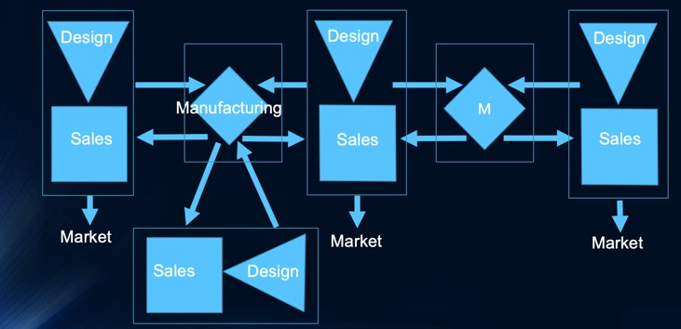
Windows & Intel = Winslet
= réseau de production modulaire Companies in each market doesn’t manufacture (pushing toyotism to the max), high tech, standard for consumers For exp, each market is: apple, windows, android à the manufacturing goes to each market
Link with slide 3: they delegate the manufacturing in Asia for example (USA designed product but manufactured in Asia)... they only search and design
Economies of scale for the companies cause since they don’t do the manufacturing, they’re light but the value of the product belong to themàreducing fixed costs (and you also don’t need a lot of people anymore) because they don’t produce
If we’re talking about cars it’s better to use schema from slide 9 because a car is a technology known since decades so if you outsource everything you will create new competitors because you give the « recipe » very easily to people who can create the car easily à in tech its more difficult to do that is you don’t master it so that’s why this scheme here on the lied is ok for high tech.
Horizontal: only design and sales in vertical, the rest is outsource (or subsidiary or relocating), one part of the SC is not controlee by you anymore

3. Tackling the gap between the EU and USA

3.1. European weakness in high sectors
- Few developments of new technologies (IT, nano- and biotechnology), more focused on imitation and assimilation of existing technologies (chemistry, automotive, traditional engineering);
- Limited R&D programmes compared to the US (university, defence): from 1.9 to 2.1% of the GDP spent on R&D for the EU against 2.4 to 2.8% for the US. Japan spend from 2.6 to 3.2%. Duplication of research project;
- Higher labour qualifications.
Nano technologies = can be defined at least as all studies and processes for the fabrication and manipulation of structures, devices and material systems at the nanometre scale, which is the order of magnitude of the distance between two atoms.
Biotechnology = the application of science and technology to living organisms, as well as to its components, products and models, to modify living or non-living materials for the production of knowledge, goods and services. → NGO
In Europe we don’t have the right qualification for innovation, and we invest not enough. We put less money in resource and development. → can see it on the deep pocket effect
Sometimes Belgian company become American company because they need much money for innovation so the American purchase them because it’s an interesting field that needs finishing to develop its full potential
The deep pocket effect

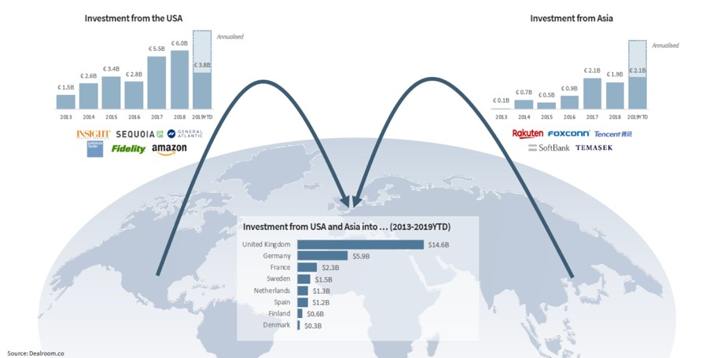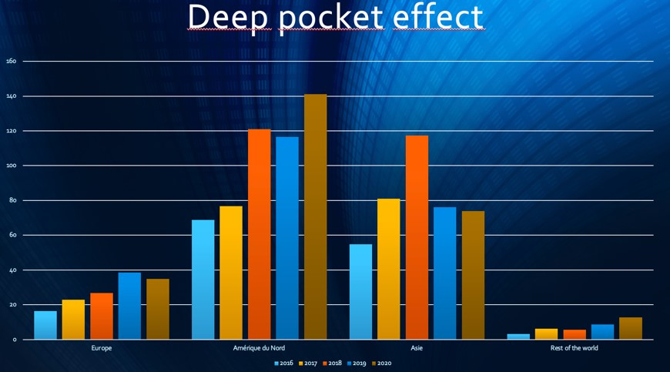

The European trail behind the digital race
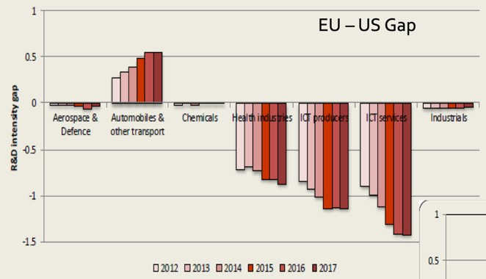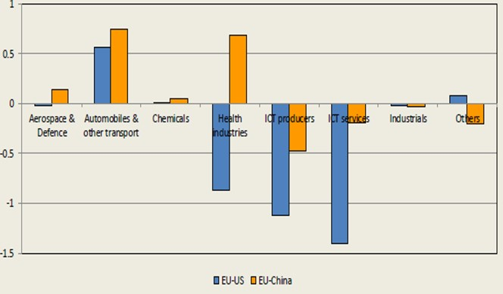

3.2. More favorable macroeconomics environment for capital accumulation in the US
- Labour market - more flexible, younger, cheaper labour force; longer working hours in the US (offset the comparable labour productivity in the EU)
- More lenient tax system for corporate companies
Companies receive more funding from the government and private companies —> more pattern —> more abilities to transform R&D in something that can be sold -> ear money —> trade results + better labor market >< EUROPE: public funding very low + EU companies invest less in R&D. By accepting more immigrants, the US can balance the aging problem of its population.

3.3. Lisbon strategy or agenda march 2000 and agenda 2020 : three pillars

« An economic pillar preparing the ground for the transition to a competitive, dynamic, knowledgebased economy. Emphasis is placed on the need to adapt constantly to changes in the information society and to boost research and development »:
- Towards a knowledge-based society;
- Higher spending on research (3% of the EU GDP by 2010 – still 2% in 2004! Target further undermined by the crisis);
- Deeper integration in the remaining domestic-oriented industries.

An economic based on knowledge = investing in education of the young people, need to boost in R & D
ECTS = The European Credit Transfer and Accumulation System (ECTS) is a points system developed by the European Union as part of the Bologna Process and the European Higher Education Area → European reform → it means that you diploma will be recognised in all European countries → a way to create more competition with all the school in Europe because employers have a bigger vision of the knowledge system → For example Maastricht have a good reputation now in Belgium thanks to the system of credit (ECTS) → It creates much more competition between the young graduated because an employer will not necessary choose a student who has known the system of education in Belgium.
EUROPEAN higher education is = It’s a single market and make more competition

3.4. R&D intensity

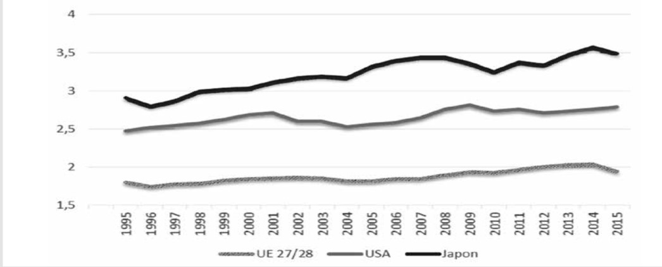

Resilient R&D gap between the US and the EU with China catching up
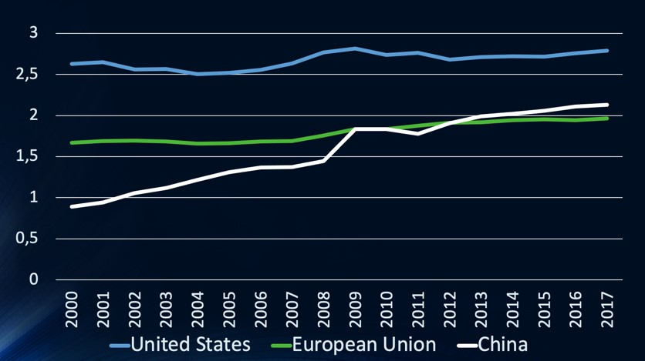

R&D intensity in the EU

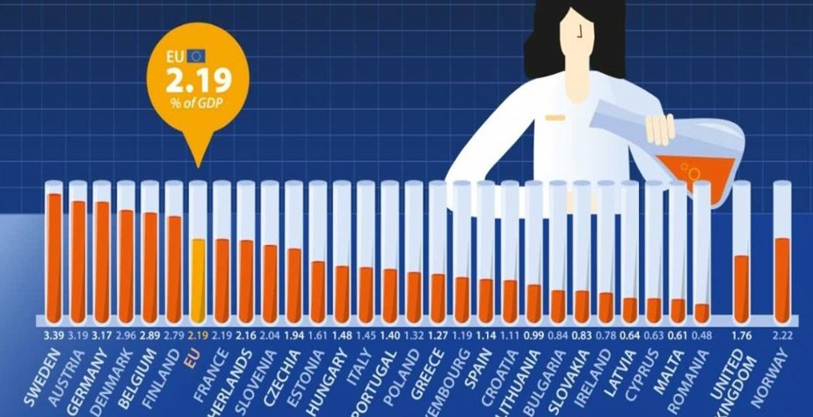

« A social pillar designed to modernise the European social model by investing in human resources and combating social exclusion. The Member States are expected to invest in education and training, and to conduct an active policy for employment, making it easier to move to a knowledge economy »: • More qualified labour force: education and training;
- More flexible labour market – flex-security;
- Increase the employment rate (the overall employment rate and the female employment rate to reach 67% and 57% respectively in 2005, 70% and 60% in 2010, the employment rate for older workers to reach 50% by 2010).

« An environmental pillar, which was added at the Göteborg European Council meeting in June 2001:
- draws attention to the fact that “economic growth must be decoupled from the use of natural resources ”
- Gaining momentum with the agenda 2020
- And now with the “Green Deal for Europe” launched in 2019

3.5. Enlargement towards Eastern Europe - Nice Treaty 2001
- Favours the organisation of regional production processes (lean production and wintelism);
- Increased social and fiscal competition within the European Union;
- Moderate increase of the size of the internal market (potential consumers): central and eastern European new member-states do only account for 5% of the EU GDP at that period (today 8%);

3.6. Agenda 2020: 5 targets for the EU in 2020 (quite the same as the Lisbon strategy with a greater dimension for Environmental goals)

1. Employment: 75% of the 20–64-year-olds to be employed; 2. R&D: 3% of the EU's GDP to be invested in R&D;
3. Climate change / energy:
greenhouse gas emissions 20% (or even 30%, if the conditions are right) lower than 1990;
20% of energy from renewables; 20% increase in energy efficiency;
- Education:
Reducing school drop-out rates below 10%;
At least 40% of 30-34–year-olds completing third level education;
- Poverty / social exclusion:
At least 20 million fewer people in or at risk of poverty and exclusion.

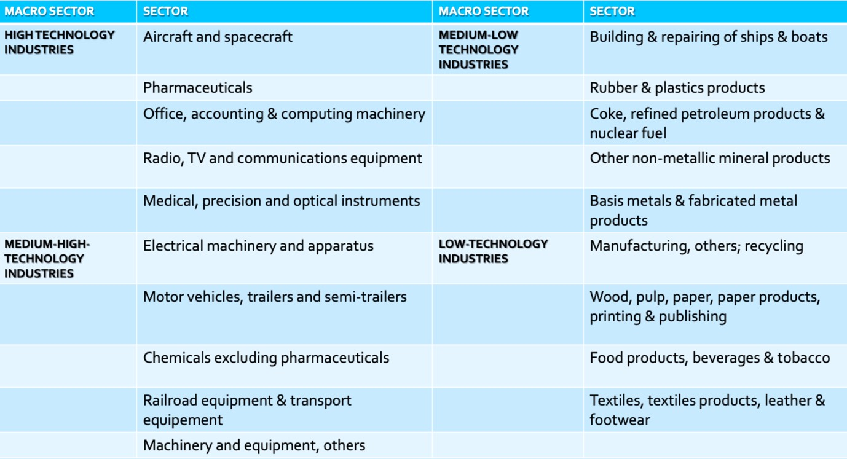

meeting between diffrent member state to discuss a subject
Ireland was colonized by the UK
army that wanted to win back the nothern part of the island
Personne physique ⁵ “Colonies Françaises d’Afrique” (1945-1958) and “Communauté financière d’Afrique” now.
American civil war
many people coming from different places
They use defensive cartel tactics (they decide to raise their costs and the customer has no choice to pay more for the same good): (10 000 identified cartels, among which 2500 in Germany, controlling 30 to 50% of international trade transactions).
Transfert américain de technologie et de savoir-faire de production standardisée à grande échelle vers les entreprises européennes. ¹⁰ Commonwealth = organisation that the UK set up with the former colonies which is a privileged access to every market
Appel d’offre
South-Korea, Taiwan, Hong-Kong and Singapore
Coûts irrécupérable
The money you give to help poor countries
See annexe given
competitivity hors prix : si les prix augmentent on ne perds pas bcp de pdm, les gens n’achètent pas le produit pour le prix mais pour la qualité
Biens d’équipement
Biens de consmmation

